Learn PA

Coaching Actuaries

Video notes

March 2023

Contents

2.2.1 Handling Numeric Vectors 2

2.2.1 Handling Factors 3

2.2.2 Handling Missing Data 5

2.2.3 Feature Creation 7

3.2.1 Main Idea and Key Outputs 8

3.2.1 Higher-Order Terms 11

3.2.1 Dummy Variables 12

3.2.1 Interactions 14

3.2.2 t Tests 15

3.2.2 F Tests 16

3.2.3 Key Assumptions and Violations 17

3.2.3 Residual Analysis 18

3.3.1 AIC and BIC 18

3.3.1 Forward Selection 19

3.3.1 Binarization 20

3.3.1 Backward Selection 21

3.3.1 Comparing Stepwise Procedures 22

3.3.2 Ridge Regression 22

3.3.2 Cross-Validation 24

3.3.2. Lasso Regression 25

3.3.2 Elastic Net 26

3.3.2 Some Technical Details 27

3.4.1 Main Idea 28

3.4.1 Key Metrics 29

3.4.1 Hypothesis Tests and Overdispersion 29

3.4.2 Various Regression Models 30

3.4.2 Weights 31

3.4.3 Logistic Regression 31

3.4.3 AUC 33

3.4.3 Handling Bernoulli Overdispersion 35

3.4.4 Poisson Regression 35

3.4.4 Handling Poisson Overdispersion 37

4.1.2 Constructing a Regression Tree: Part 1 38

4.1.2 Constructing a Regression Tree: Part 2 41

4.1.2 Pruning a Regression Tree 44

4.1.2 The Train Function: Part 1 47

4.1.2 Competitor and Surrogate Splits 50

4.1.2 Constructing a Classification Tree 52

4.1.3 Pruning a Classification Tree 54

4.1.3 The Train Function: Part 2 54

4.1.3 Advantages and Disadvantages 55

4.2.1 Random Forests 56

4.2.1 Boosting 58

4.2.2 Oversampling and Undersampling 63

4.2.2 The Train Function: Part 3 64

5.1.1 Principal Components Analysis 69

5.1.1 Technical Details 74

5.2.1 k-Means Clustering 75

5.2.2 Hierarchical Clustering 77

## 2.2.1 Handling Numeric Vectors

1. Make a factor version

2. Create factor of intervals

Make a factor version of a variable

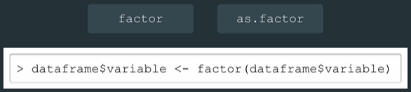

To determine how many unique values a variable has

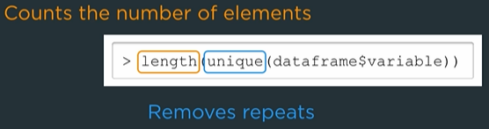

Creating factors from intervals

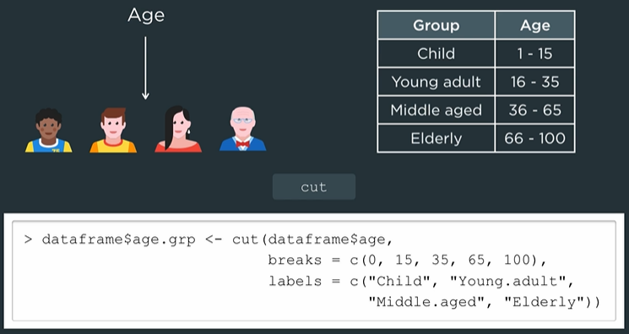

When using cut the factor values can be different than the numeric factor values

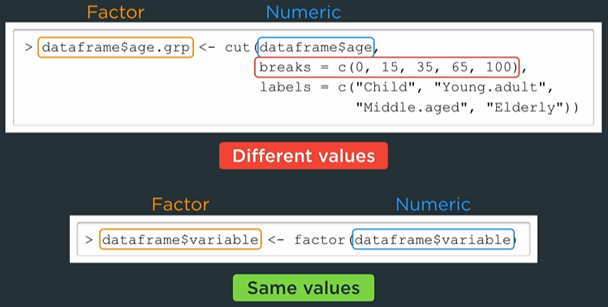

## 2.2.1 Handling Factors

1. Change specific elements

2. Make a numeric version

3. Combine levels

4. Relevel

Change the factor levels by setting the value. If the given value is not one of the possible factor levels R will set the level to <NA>

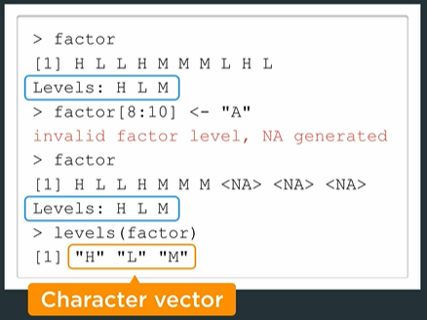

If factor consists of numbers alone then we can create a numeric version that retains the values using

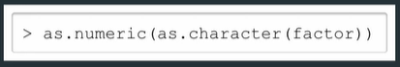

This is most common when creating a factor from a binary target

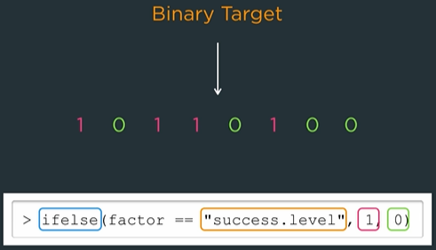

Combining levels presents several problems such as

1. Renaming a level
2. Combining more than two levels
3. Having replaced levels remain (can still be dropped with droplevels)

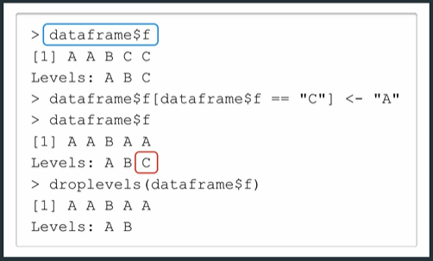

Plyr::mapvalues solves these issues

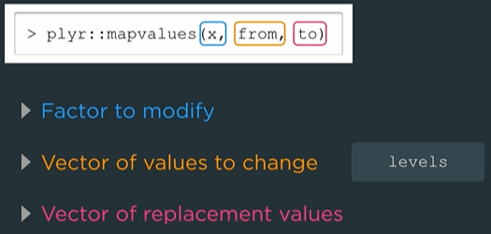

Examples of mapvalues

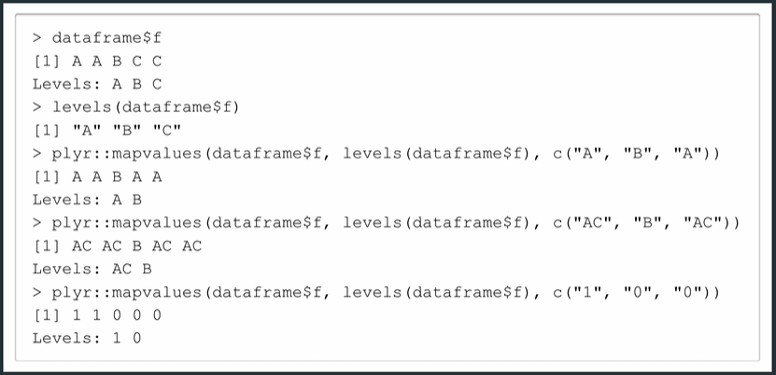

By default, the first level listed is the reference level (or baseline category) but can be changed using relevel

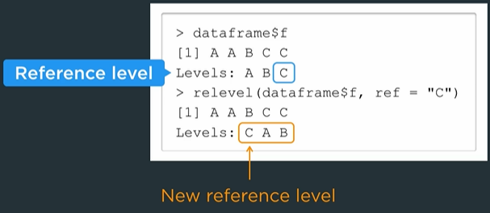

Reference level is often based on preference. It’s common to choose the level with the most observations.

SOA uses code like the following to relevel one factor

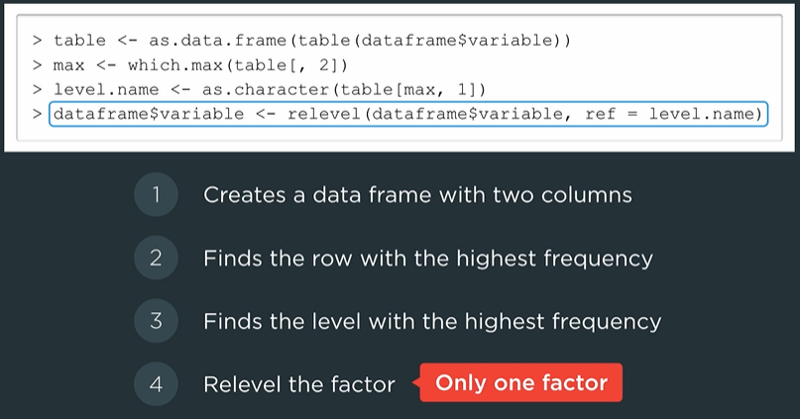

We can relevel multiple factor variables using a for-loop

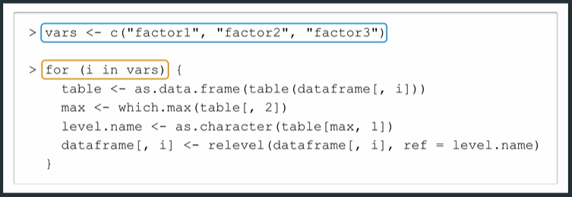

## 2.2.2 Handling Missing Data

In R <NA> (Not Available) is a special value and not a level. We can replace factors with <NA> values by a “unknown” or “missing” level. We can get filter vector on <NA> with

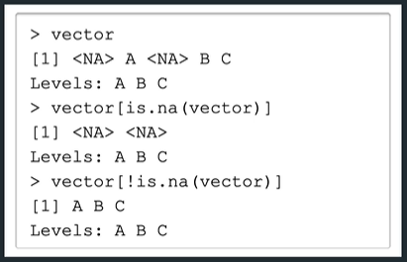

Find the proportion of <NA>s in each column of the dataframe

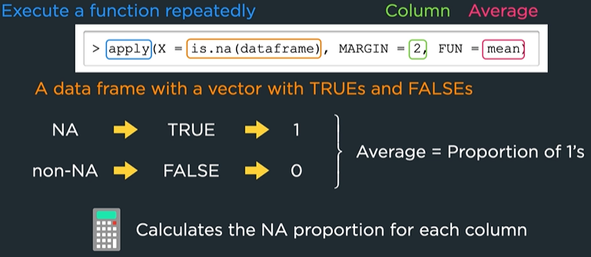

Can also use

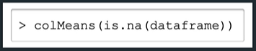

We can fix missing data by removing it from the rows or columns

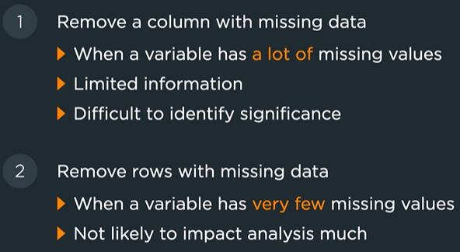

Remove columns entirely that have missing data using

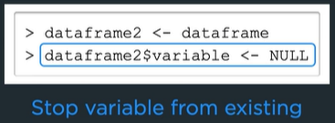

Remove rows with missing data using

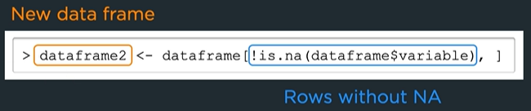

To remove rows that have any missing data

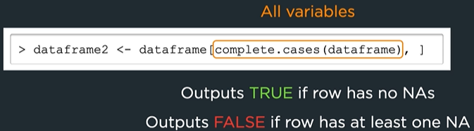

## 2.2.3 Feature Creation

1. Compound variables

2. Appending multiple features

Make a compound factor by merging two other factors. We might do this to combine two separate but overlapping factors or to include an interaction.



Append new features to a dataframe using cbind. We might use this for binarization or Principal Component Analysis (PCA).

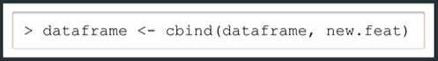

## 3.2.1 Main Idea and Key Outputs

Lm = linear model

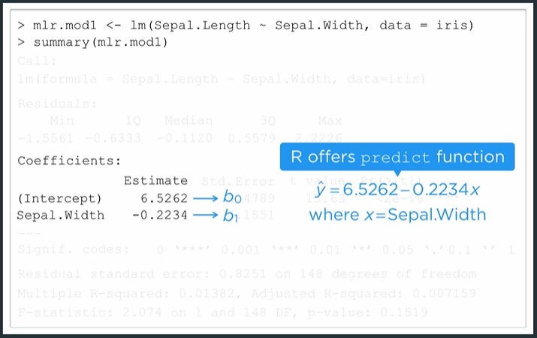

Must provide a dataframe of predictors if predicting on data other than the training set

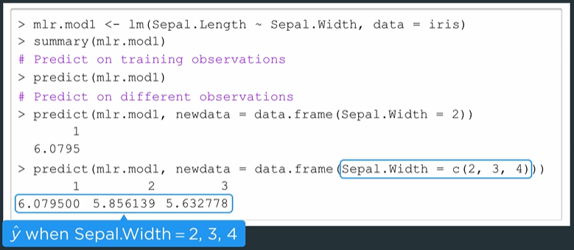

Formula object symbols include ~ + . - : *

Tilde ~ means “explained by” e.g. target ~ predictors.

Plus + mean “include”, not arithmetic addition

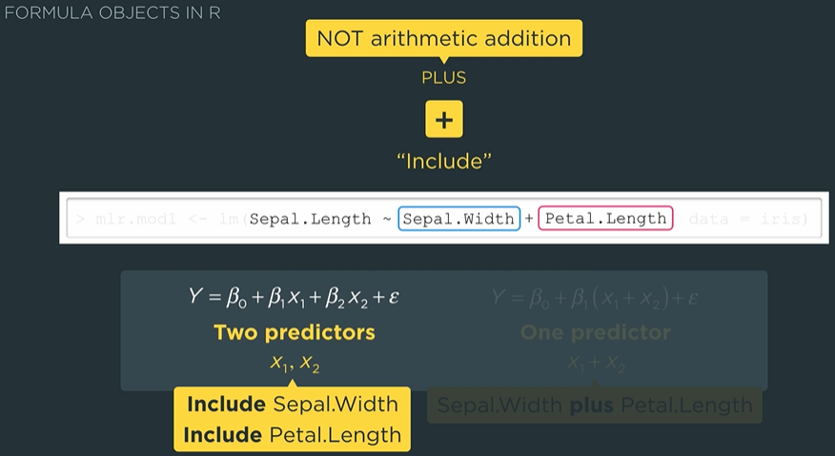

Period . means all remaining variables

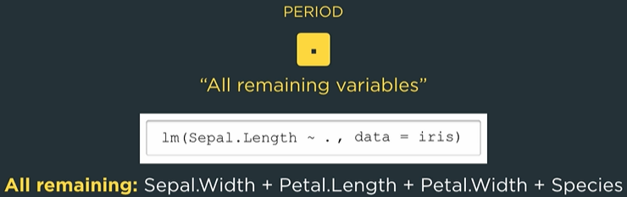

Minus sign – means to exclude a variable

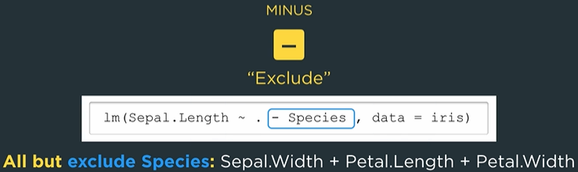

Interpreting coefficient estimates

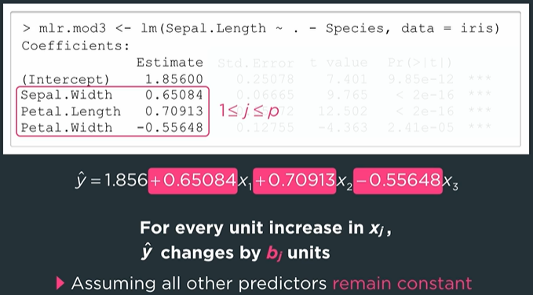

When predicting new data we still have to provide referenced variables even if they are excluded from the formula. So newdata does require specific columns but the model will only use the ones that matter to make predictions.

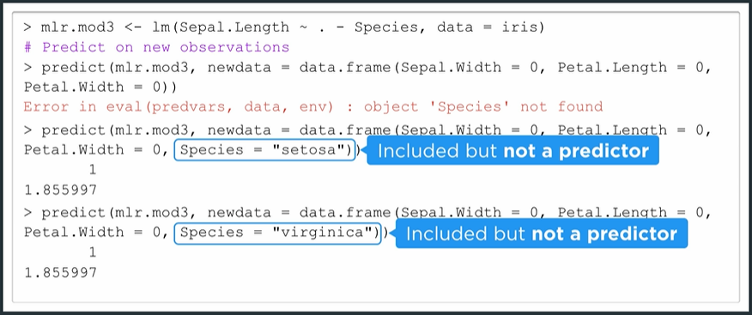

## 3.2.1 Higher-Order Terms

Incorrect



Correct

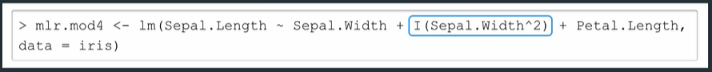

You can do this..

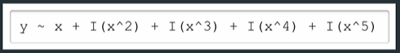

But using poly create orthogonal polynomials



The two models will have different coefficient estimates but identical predictions

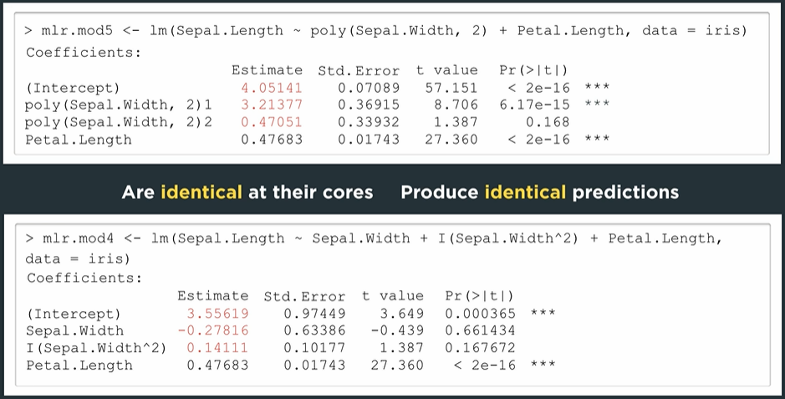

We can force poly to use the **ɪ** polynomial terms by setting the “raw” argument to true

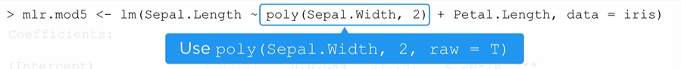

## 3.2.1 Dummy Variables

Predictors can be factor variables

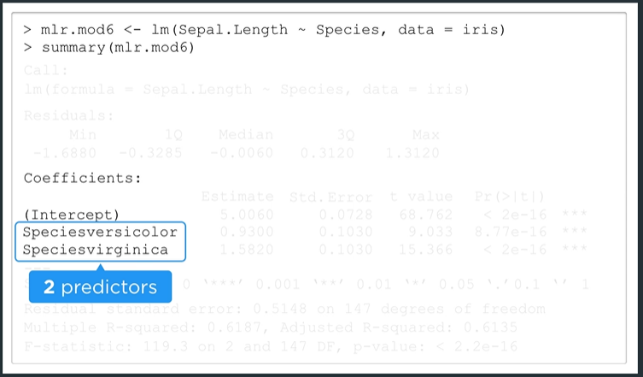

Binarize factors with the dummyVars function

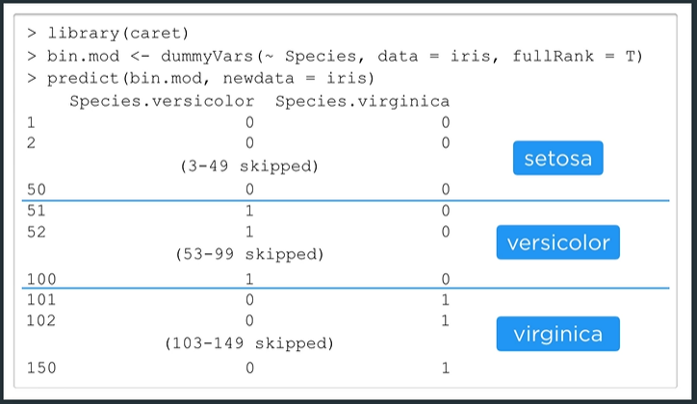

This will one-hot encode the species levels. Now we can use species to predict sepal length:  
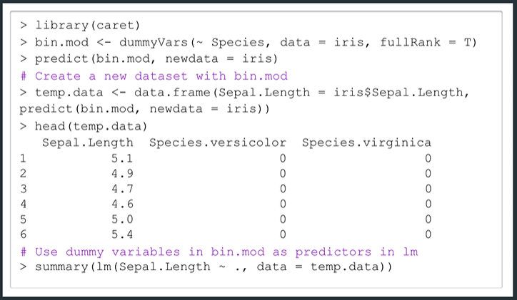

This model gives us

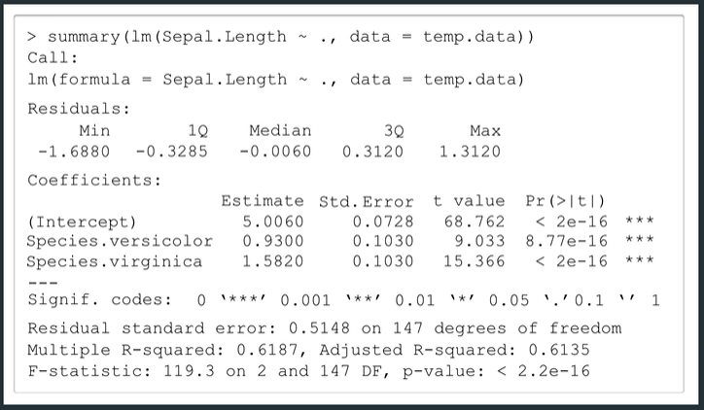

Which is an exact match to the mlr output  
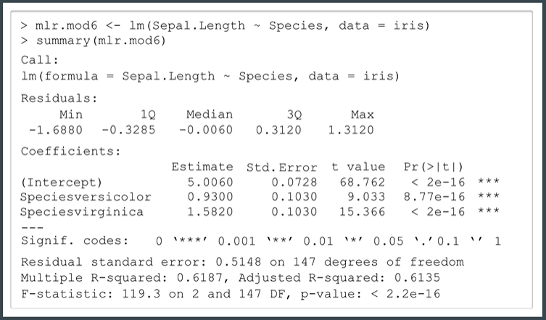

## 3.2.1 Interactions

Formula objects in R



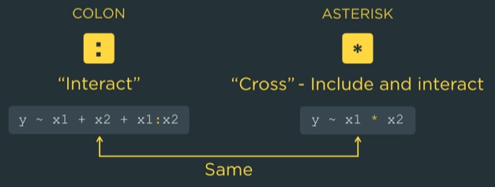

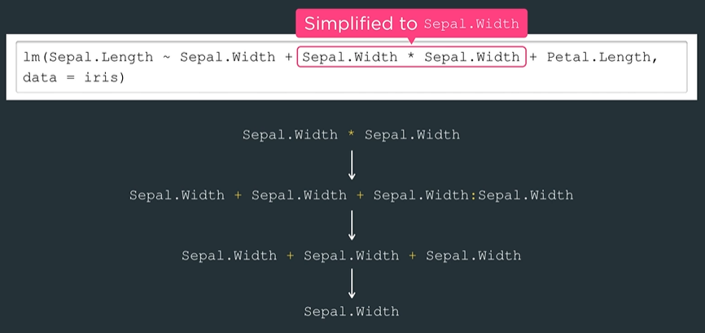

When crossing with factors we get parameter estimates for each level’s interaction

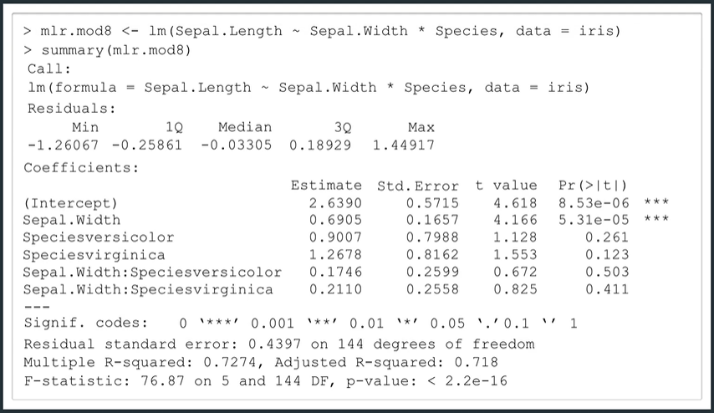

## 3.2.2 t Tests

t-Tests are done with respect to the reference level

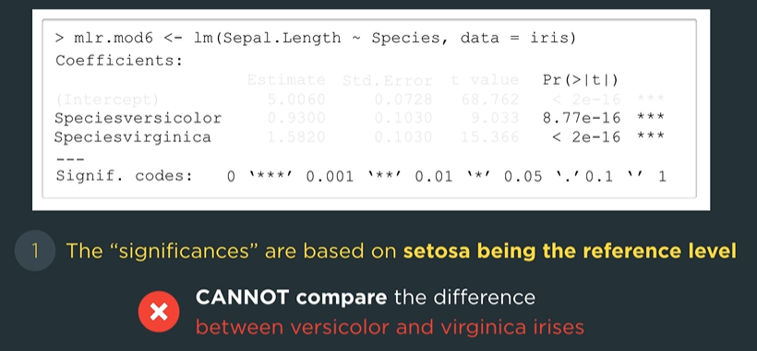

Use hierarchical principle when removing interaction terms



## 3.2.2 F Tests

We can only apply F-tests with MLRs in limited situations

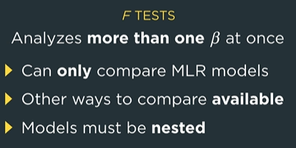

By default, the null hypothesis of the F-test is that all coefficients are zero. The alternative hypothesis is that at least one is not zero. We can compare nested model using ANOVA, which takes the smaller model as the first argument.  
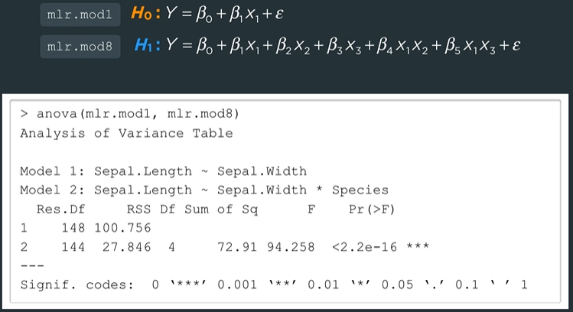

## 3.2.3 Key Assumptions and Violations

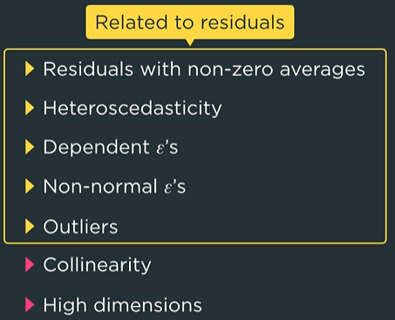

dummyVars uses fullRank = FALSE by default. Meaning each factor level will have its own dummy variable. This will cause multicollinearity.

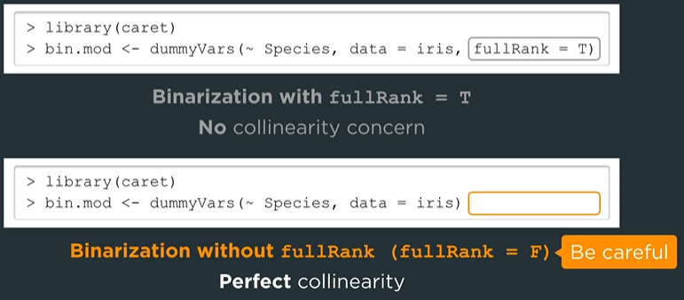

As the number of predictors increases, we need more and more data to accurately describe all interactions.

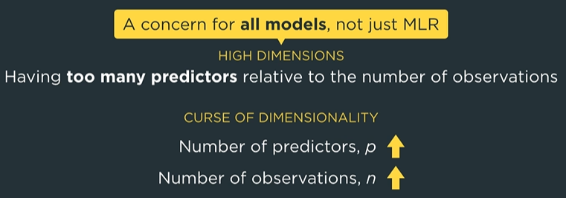

## 3.2.3 Residual Analysis

The function plot will generate four diagnostic plots. The first two are 1. Residuals vs Fitted 2. Normal Q-Q plot

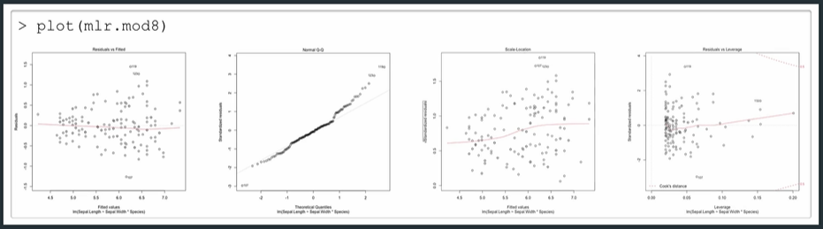

For the residual vs fitted plot we are concerned with three things

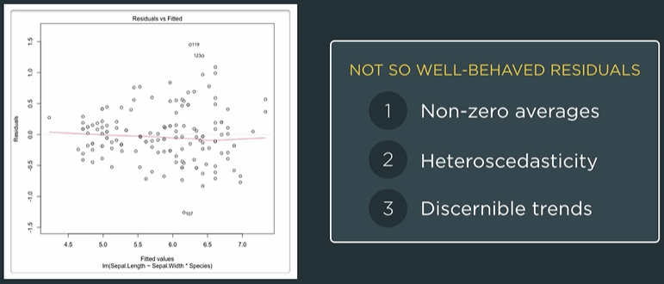



## 3.3.1 AIC and BIC

Akaike / Bayesian Information Criterion.

AIC = SSE + 2*p

BIC = SSE + ln(n)*p

AIC/BIC can be computed without a test set and it’s more likely that a smaller p will minimize BIC i.e. it favors models with fewer predictors as compared to AIC.  
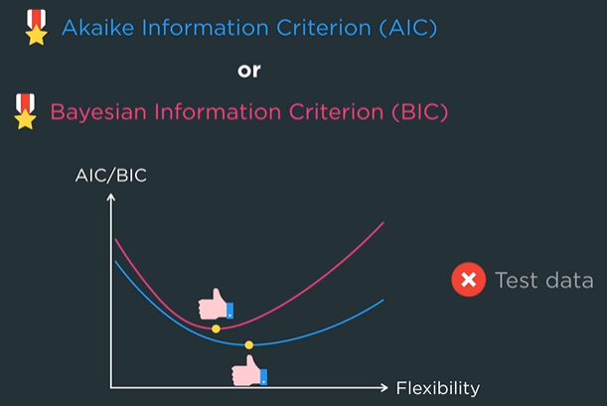

## 3.3.1 Forward Selection

Forward Selection in R requires the lower and upper model for a starting and stopping point

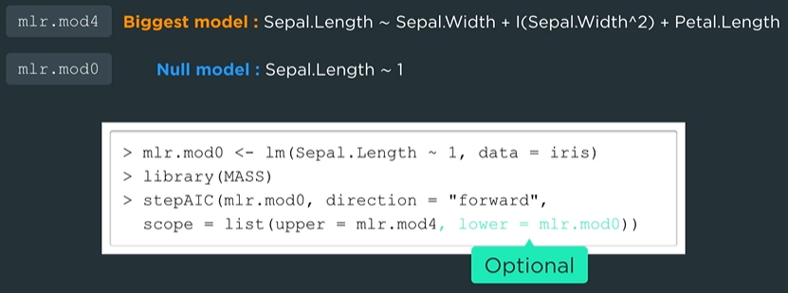

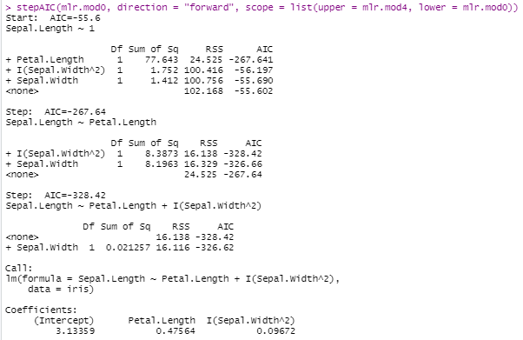

To find BIC we use the stepAIC function again but set k = ln(n)

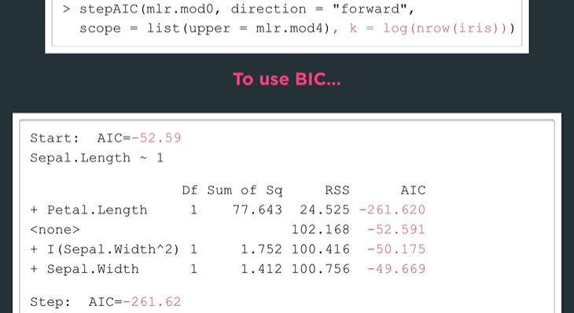

The values will be BIC even though the output shows AIC

## 3.3.1 Binarization

Forward selection does not consider dummy variables as separate predictors. But factors may have levels that are predictive and some that are not. Stepwise selection can handle this is we perform binarization and treat the dummy variables as standalone predictors.  
  
When adding they dummy variables for species, we also need to exclude the species column from the dataset.

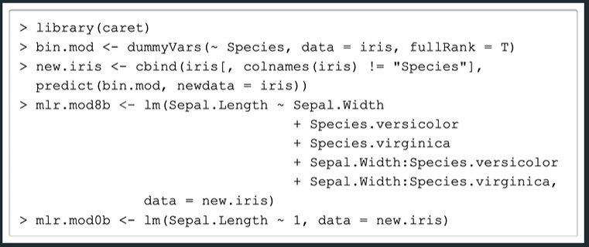

## 3.3.1 Backward Selection

Interaction terms must be removed before individual terms become candidates for dropping

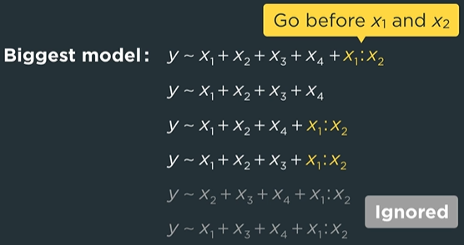

When we do not specify scope (as we did in forward selection) then the default direction is backward

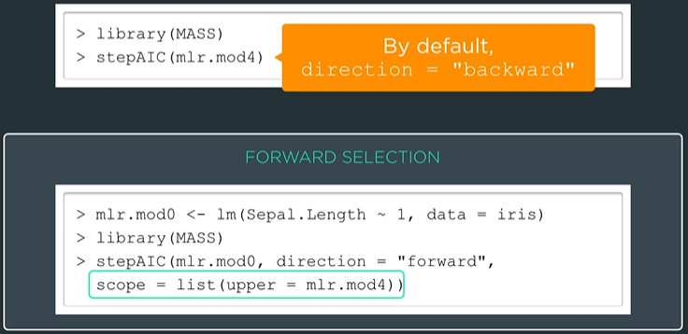

## 3.3.1 Comparing Stepwise Procedures

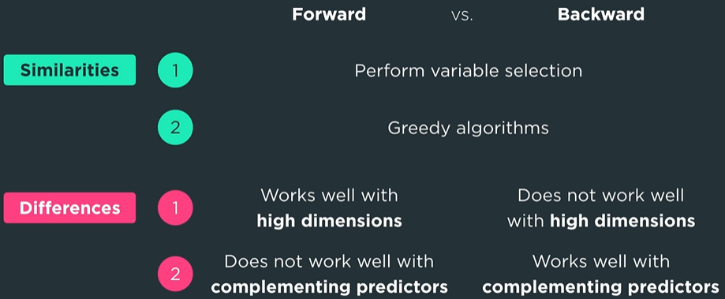

Generally, these two combinations are used



## 3.3.2 Ridge Regression

Use glmnet library with alpha = 0 to get ridge regression. By default, glmnet uses standardize = TRUE so we don’t have to scale the predictors.

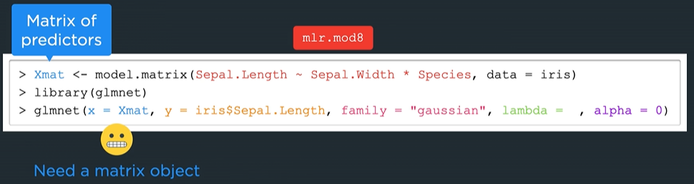

Model.matrix will automatically perform binarization and include an intercept column.

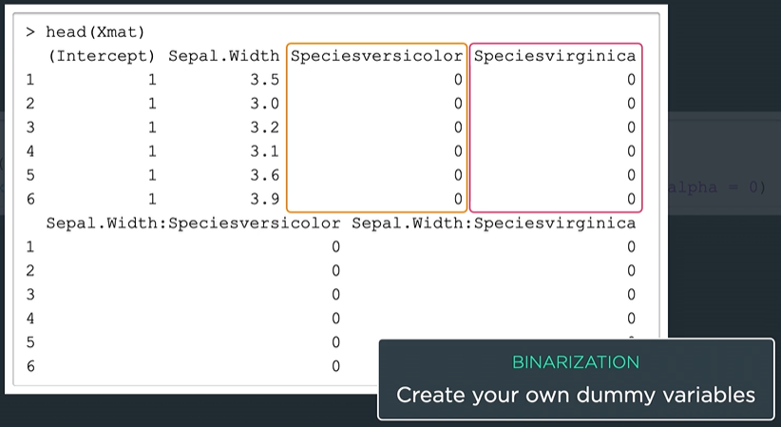

When lambda = 0 there is no penalty and hence we get the normal MLR estimates

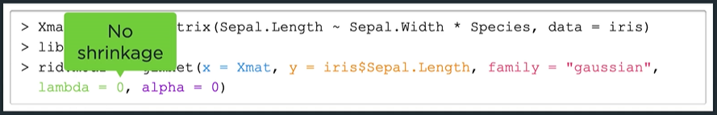

Notice the intercept is given separately

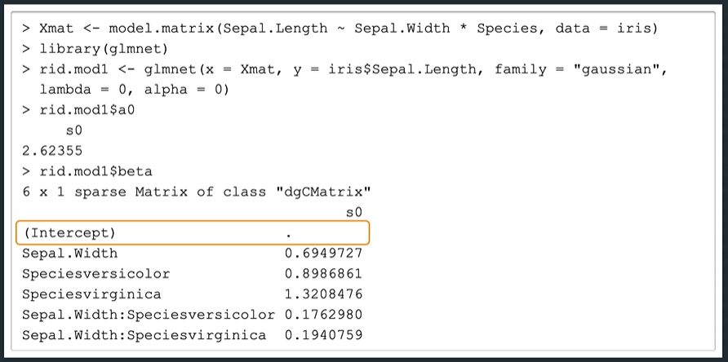

Coaching Actuaries prefers this code instead of the above from the SOA

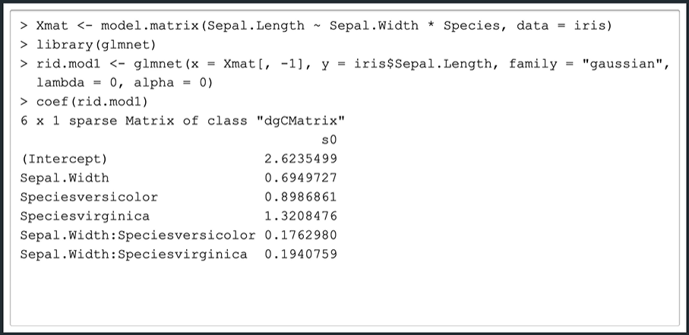

Note we can get the coefficient estimates to match those from MLR by adjusting the convergence threshold parameter (thresh).

By increasing lambda, we reduce flexibility and approach the null model

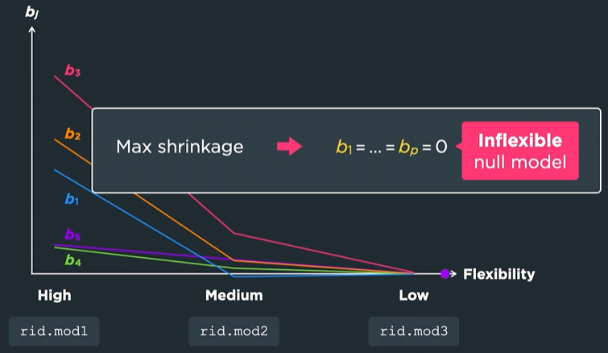

We use cross validation to fine-tune the value of lambda.  
  
Ridge regression does not perform variable selection

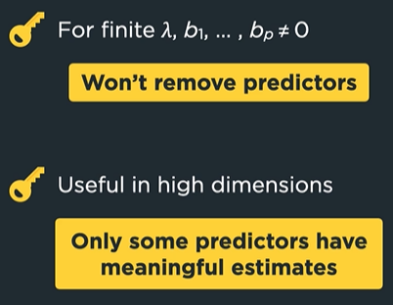

## 3.3.2 Cross-Validation

K-fold cross validation needs only the training set. We can perform cross-validation in R, the default is ten folds (nfold = 10). It’s important to set the seed first for reproducible results.

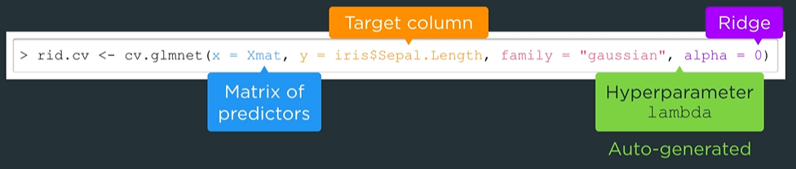

The function will generate (<= 100) its own candidate lambda values if we don’t specify.

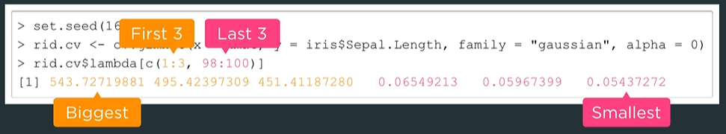

Which lambda produces the lowest CV error? Use $lambda.min

The perform ridge regression with the best lambda from CV

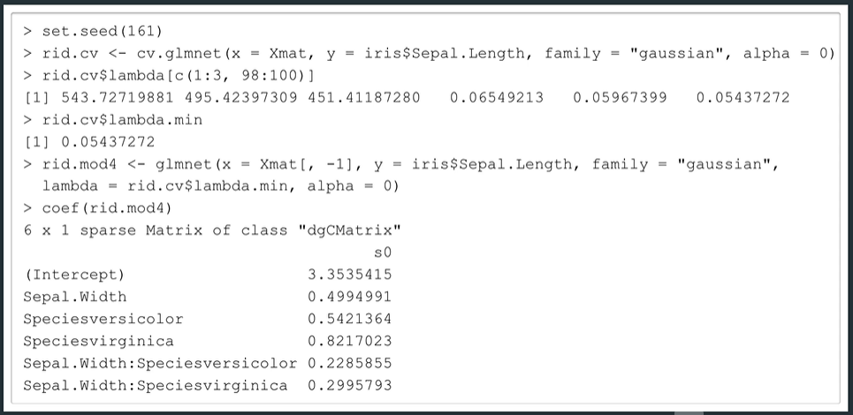

## 3.3.2. Lasso Regression

Least Absolute Selection and Shrinkage Operator. Lasso regression can perform variable selection

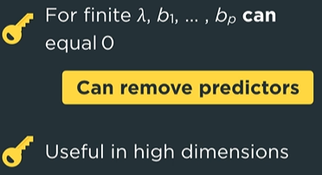

To run Lasso instead of Ridge regression all we set alpha = 1

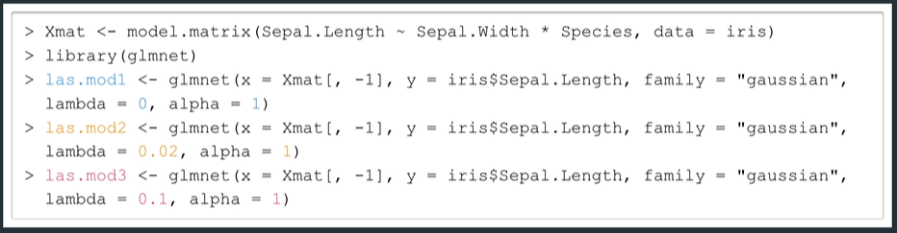

Lasso ignores the hierarchical principle.

$Lamba will give the values of lamda used. Lambda.min will give the lambda which minimizes the Lasso/Ridge objective function.

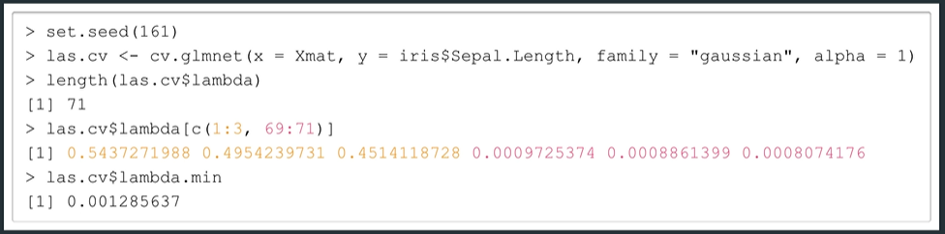

## 3.3.2 Elastic Net

Constraint is a weighted average of those from Ridge and Lasso (hyperparameter alpha = 0 Ridge, alpha = 1 Lasso). We can tune alpha using cross validation but it’s common to do so manually.

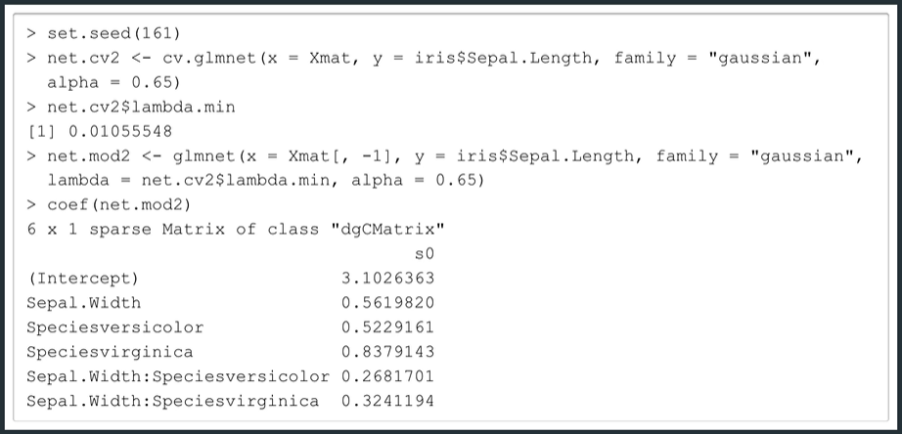

Compare glmnet models using the training RMSE. The syntax is different than MLR because we must specify the predicted values in the argument newx.



Lambda is inversely related to flexibility for fixed alpha.

## 3.3.2 Some Technical Details

The lambda in alpha in the glmnet function are not the same as given in the formula



Both alphas in [0,1] and both give Ridge/Lasso at the endpoints.

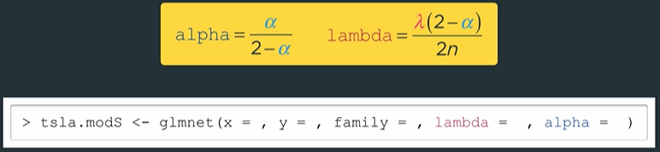

The one standard-error rule. We choose the lowest flexibility model with CV error within one standard deviation.

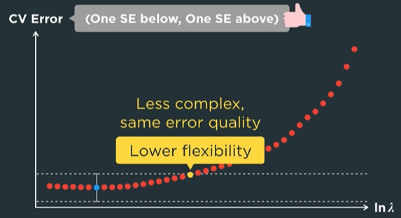

Minimum and one standard error rule lambda

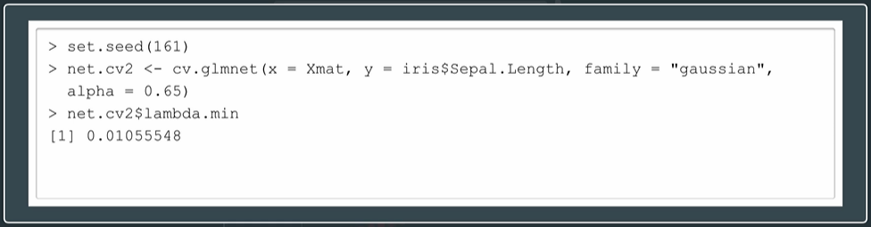

## 3.4.1 Main Idea

General Linear Models (glm) need a distribution and a link function. Default link argument is the canonical link.

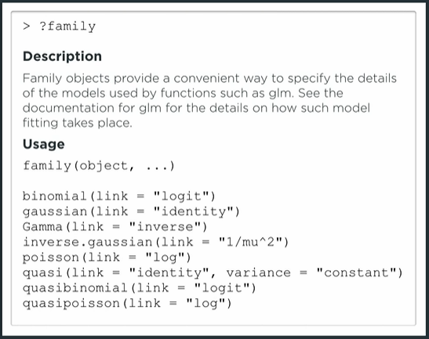

Parameters are estimated using maximum likelihood estimation (MLE). Not necessary for glm to minimize SSE i.e. the objective function of GLM is different than MLR.

Beta parameters estimates embedded within theta

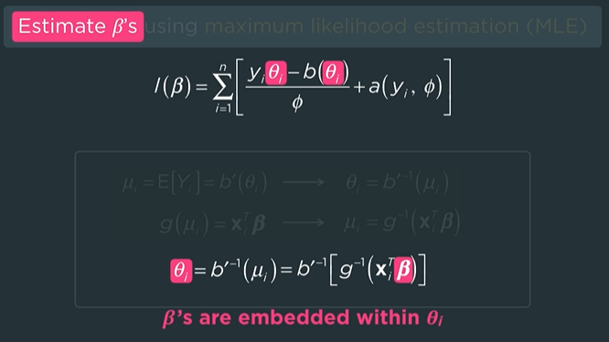

Try choosing the canonical link if the estimates have trouble converging.

## 3.4.1 Key Metrics

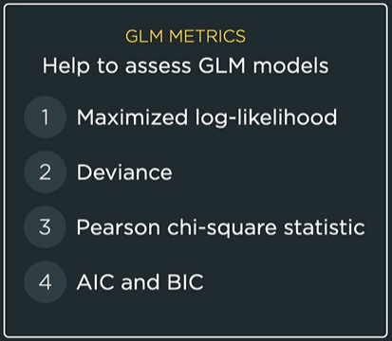

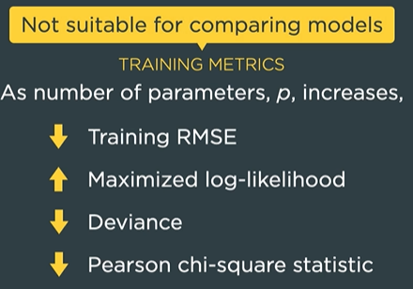

Use a test metric to compare models

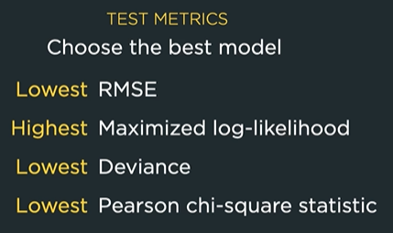

## 3.4.1 Hypothesis Tests and Overdispersion

The quasi binomial / poisson can help us model overdispersion depending on if the target variable is binary or count.

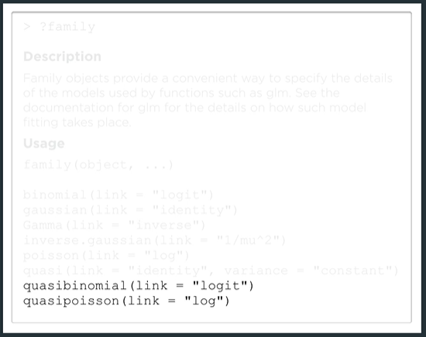

## 3.4.2 Various Regression Models

Use glm and specify the family / link

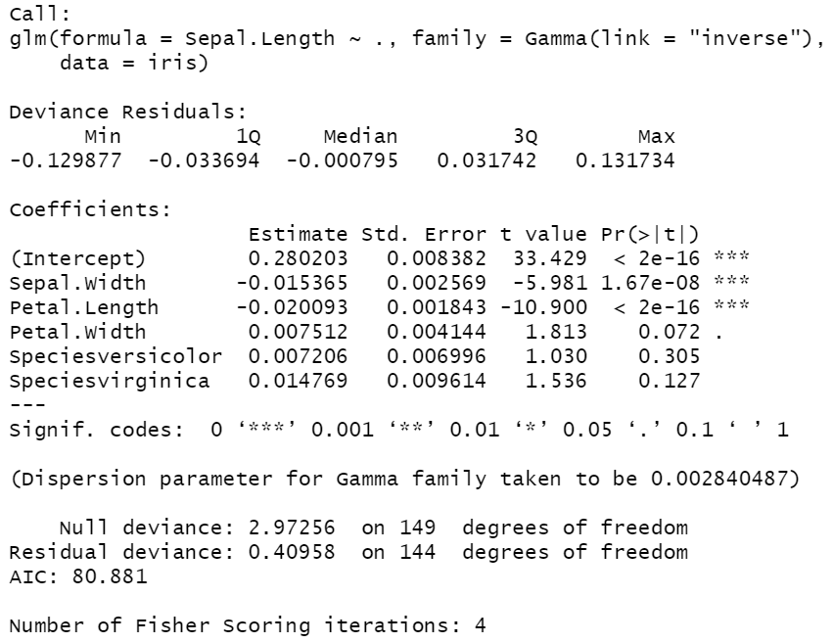

Predict does not give the training prediction of the response (mu). Instead it gives g(mu). To get the estimates set type = “response”

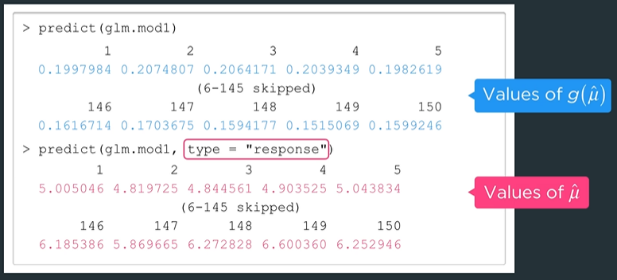

## 3.4.2 Weights

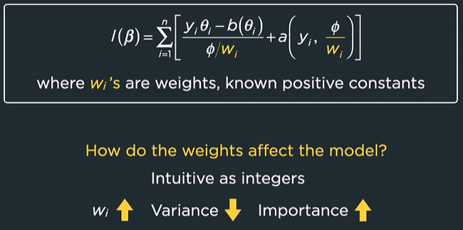

W is the column of weight values

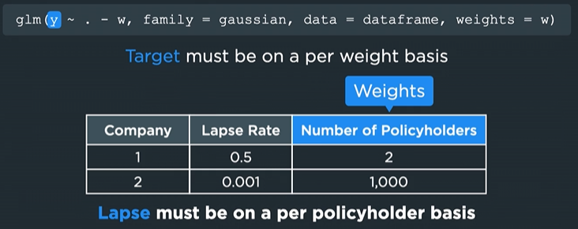

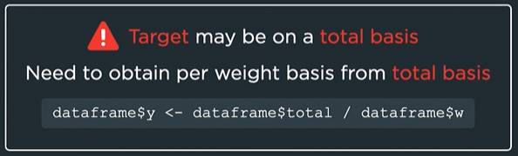

## 3.4.3 Logistic Regression

Three common link functions have domain [0,1] -> range (-inf, inf)

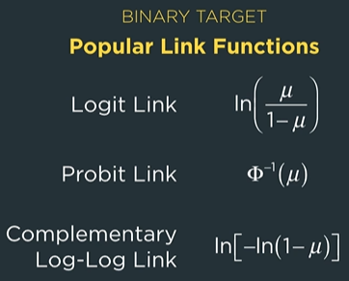

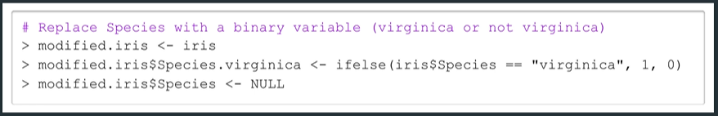

Use glm with the binomial and logit link

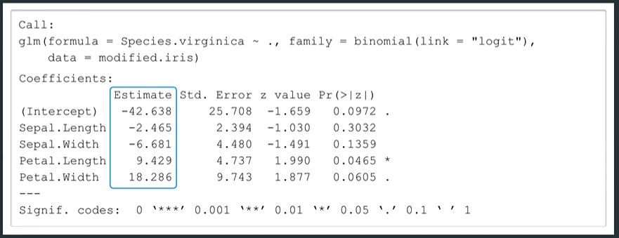

Exponentiate to get predicted odds

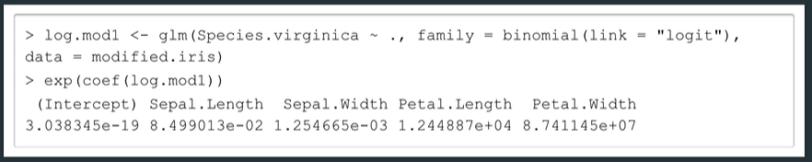

Logistic curve

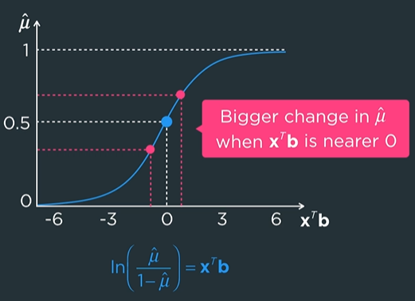

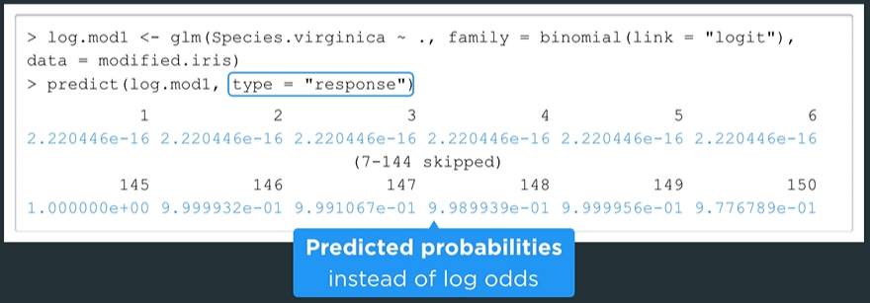

Use cutoff probability to get target prediction

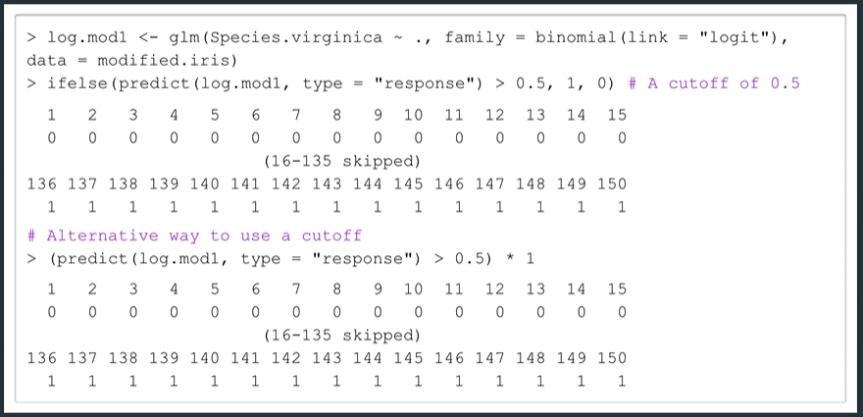

SOA uses x1 vector trick to get predictions

## 3.4.3 AUC

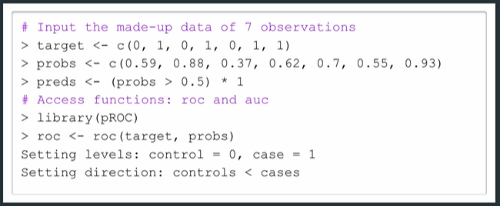

Plot the ROC curve

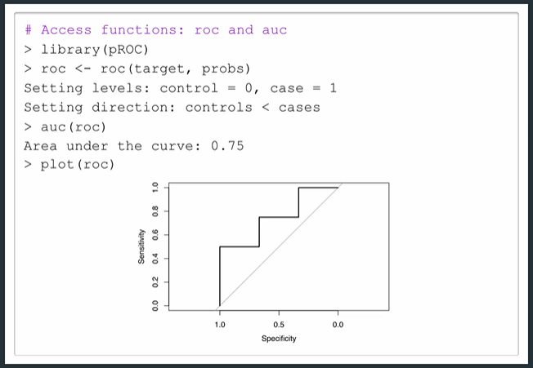

Create a confusion matrix by providing the factor version of target and predictors to the confusionMatrix function from the caret package.

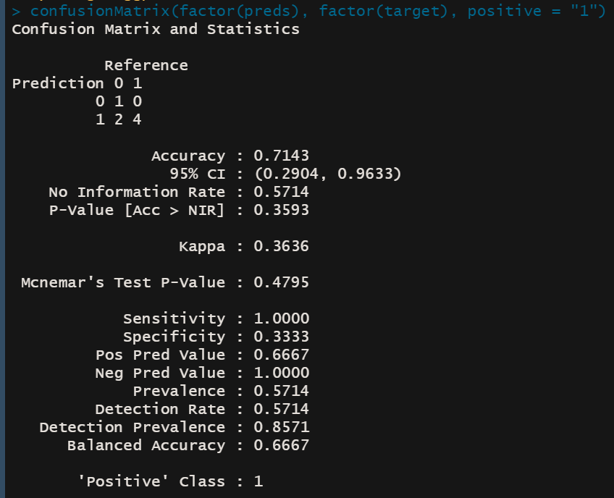

If we do not specify the value for the argument “positive” then the values for sensitivity and specificity will be switched. The confusion matrix will remain the same.

## 3.4.3 Handling Bernoulli Overdispersion

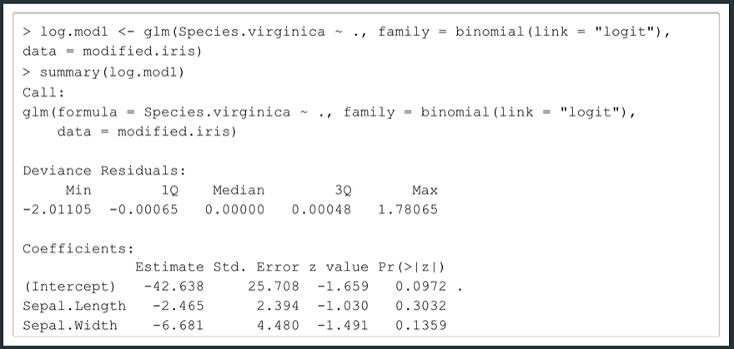

One way to approximate if there is overdispersion is to check the residual deviance and corresponding degrees of freedom. If the two numbers are roughly the same, then the model is fine (no overdispersion). If the deviance > degrees of freedom, it signals overdispersion.

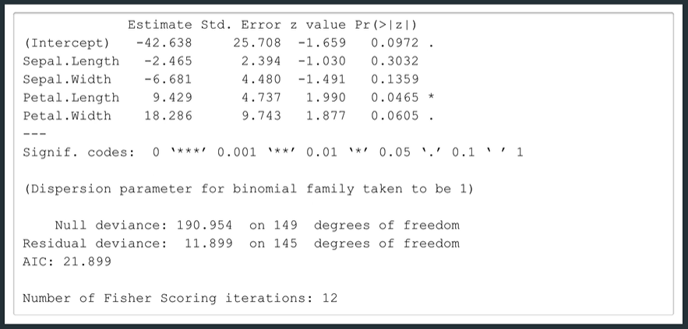

The solution is to run another glm from the quasibinomial family. The coefficient estimates remain the same, but z-tests become t-tests.  
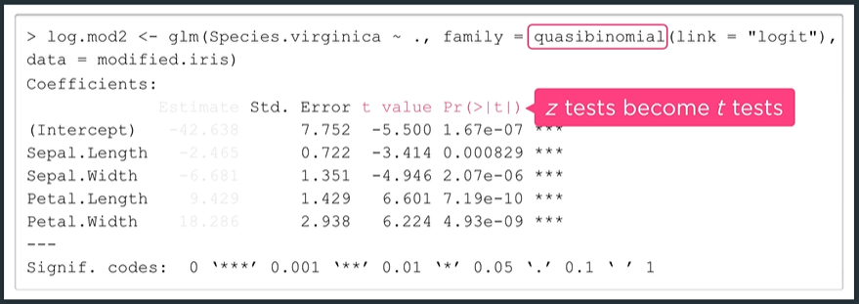

Doesn’t improve predictability but does make hypothesis tests more reliable.

## 3.4.4 Poisson Regression

Focus on glm for count targets. Predictions are mean estimates and don’t have to be integers.

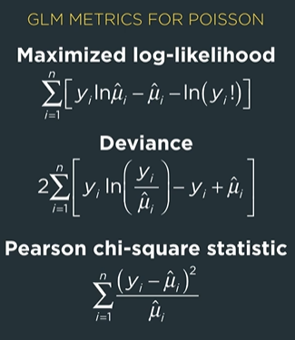

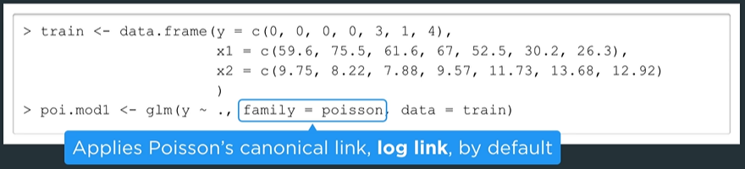

A summary for this model

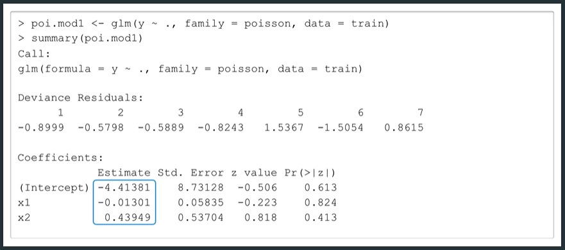

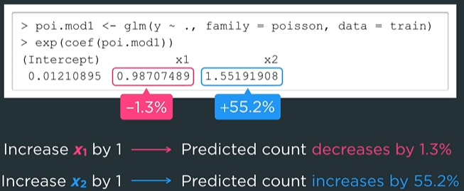





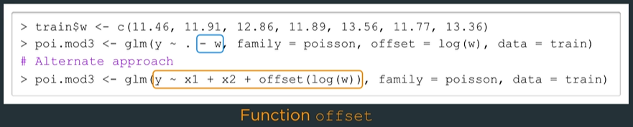

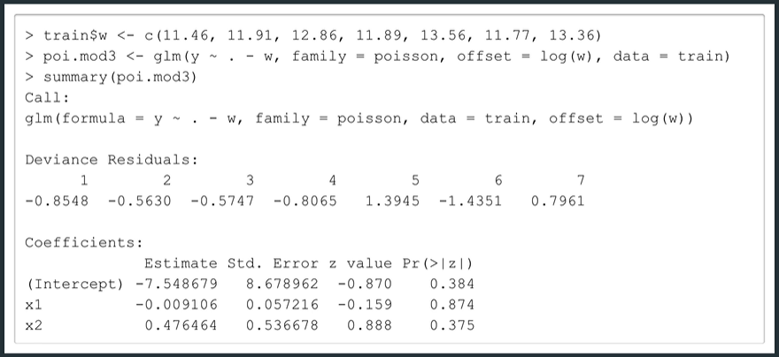

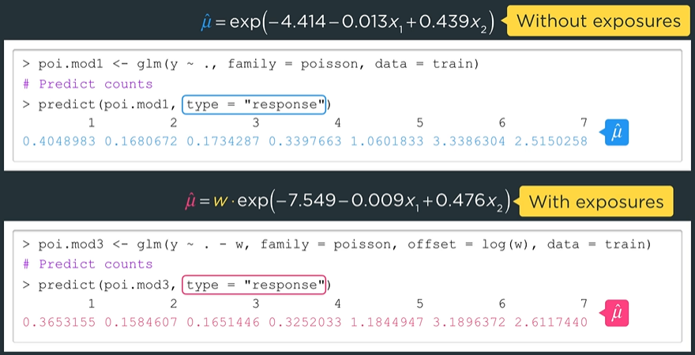

## 3.4.4 Handling Poisson Overdispersion



Set family to quasi-poisson

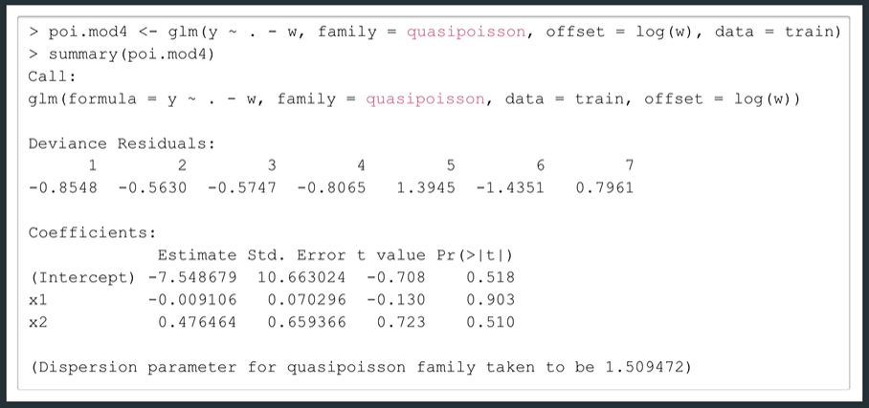

## 4.1.2 Constructing a Regression Tree: Part 1

Use the package rpart (recursive partitioning)

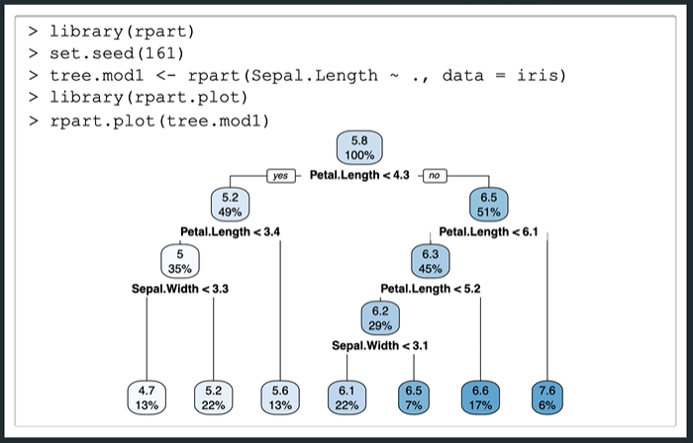

With binary recursive splitting the number of splits is one less than the number of terminal nodes

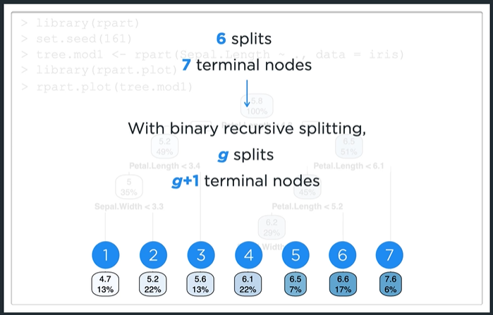

Use argument “digits” to show more significant figures

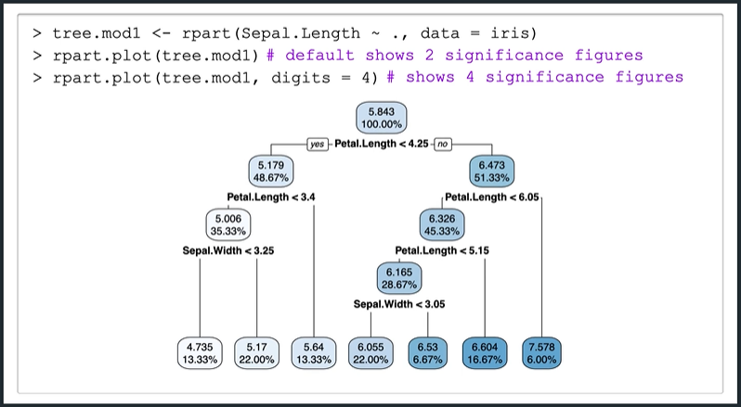

Even though we used sepal width, petal length, petal width and species as predictors. The tree splits only use petal length and sepal width.

View the tree in greater detail

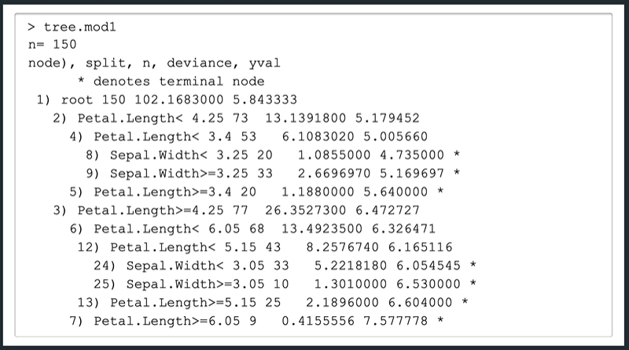

Which is consistent with R output

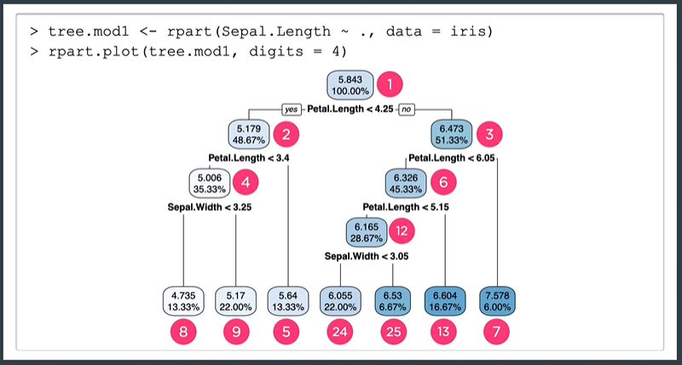

Recursive binary splitting attempts to minimize deviance

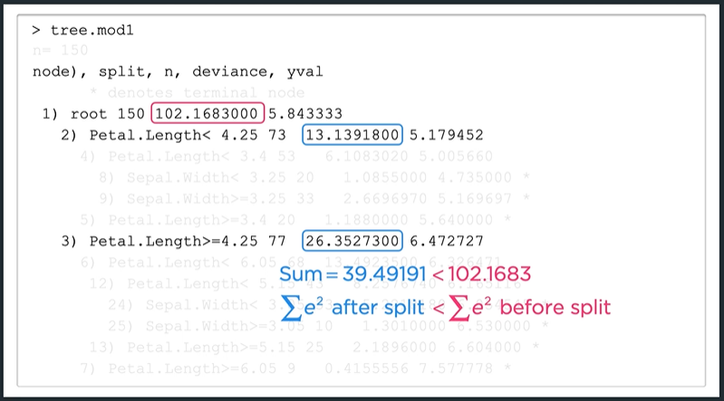

Four stopping criteria

1. Minsplit
2. Minbucket
3. Maxdepth
4. Cp (complexity parameter)

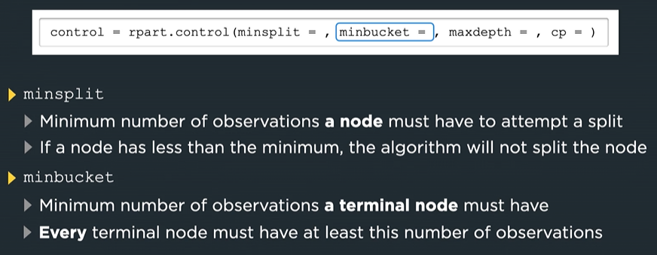

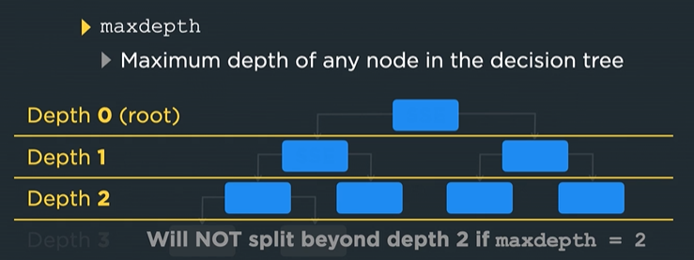

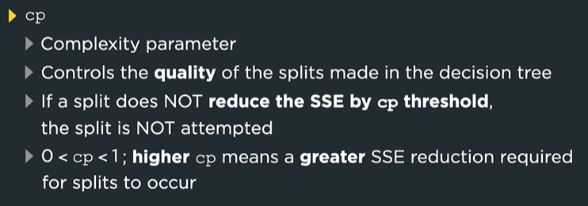

We set the seed because rpart performs cross-validation, which is crucial for pruning, to fit the regression tree.

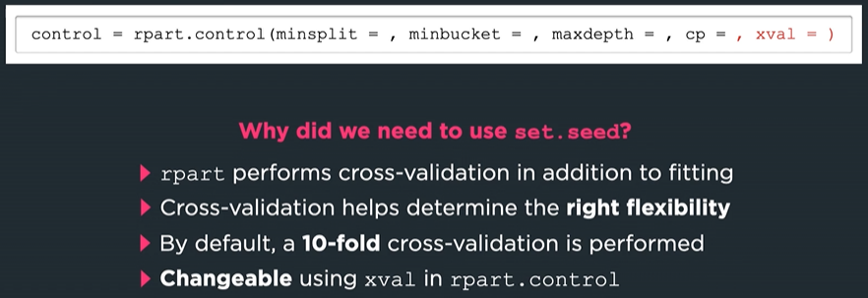

Using rpart.control we can get a more flexible tree model

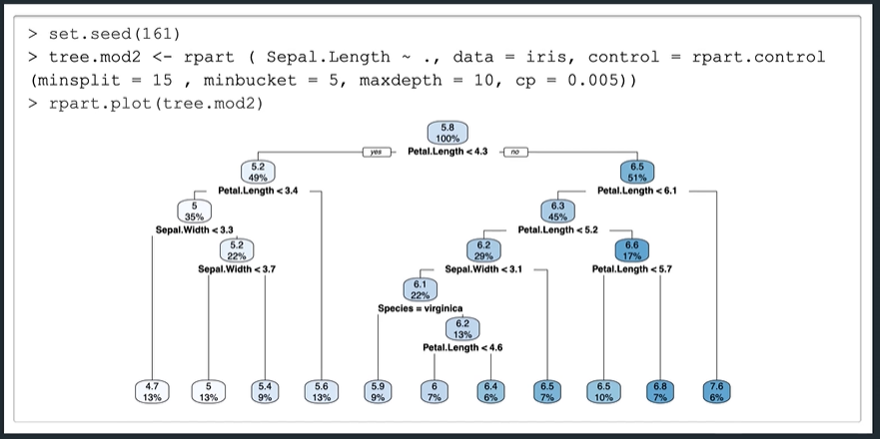

Rpart does not convert factors into dummy variables but works with factors without conversion. Predictors do not need to be numerical to run decision trees.

In summary  
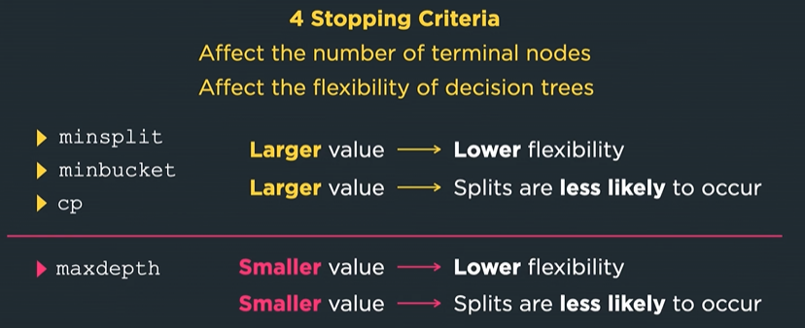

## 4.1.2 Constructing a Regression Tree: Part 2

Constructing a regression tree for a count target. A Poisson tree.

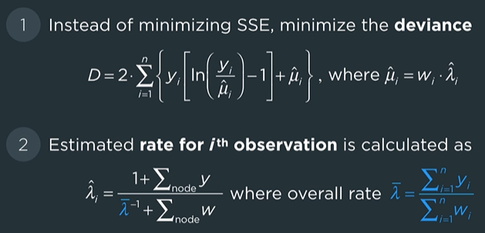

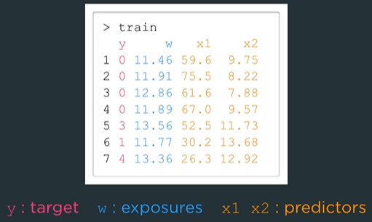

Provide exposures and target variable. Use method = “poisson” to model a tree with a count target.

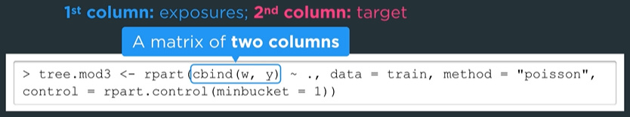

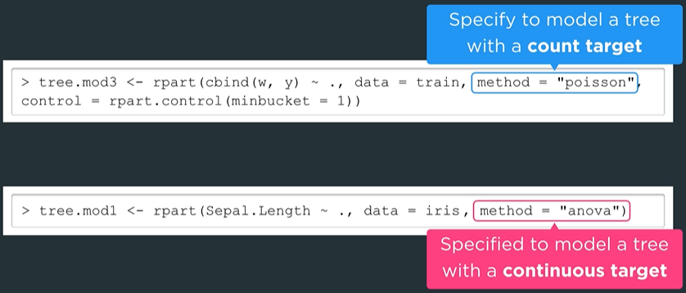

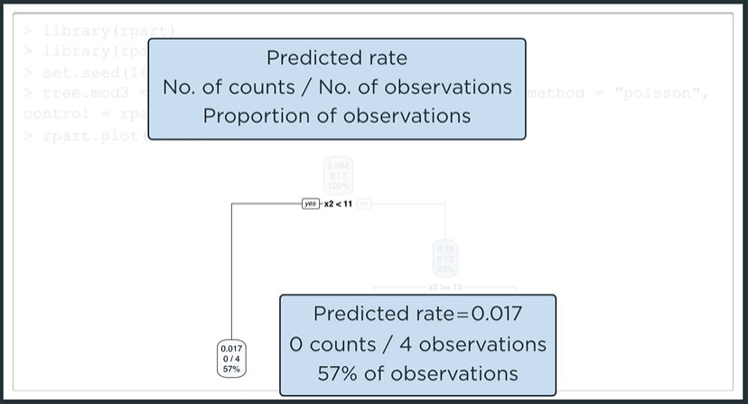

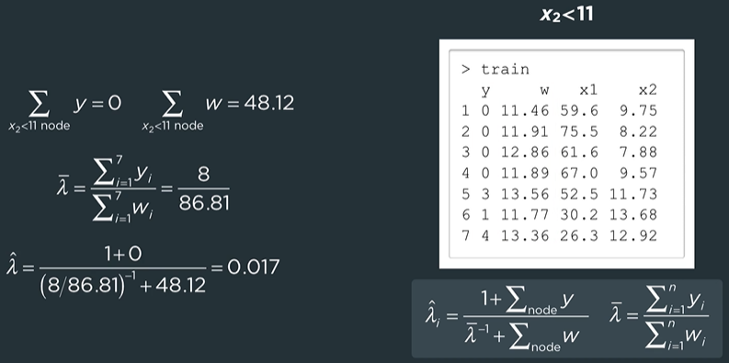

Predict produces rates and not counts

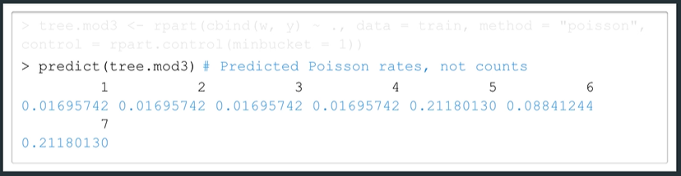

Unlike what happens for the Poisson regression model

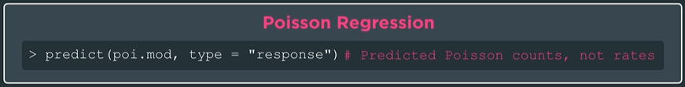

To get the counts we take the rates times the exposures

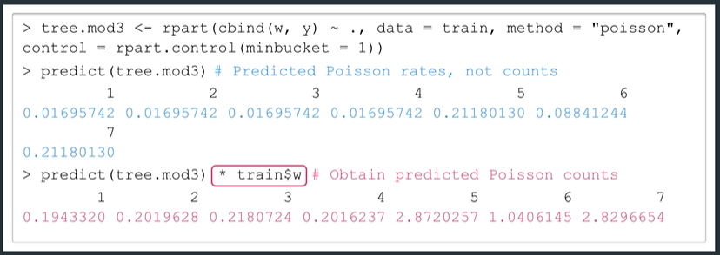

Poisson tree with and without exposures

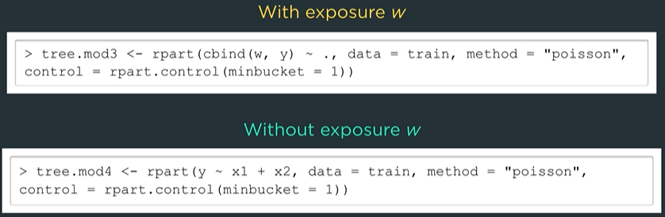

without exposures it is as if exposure for each observation is equal to one.

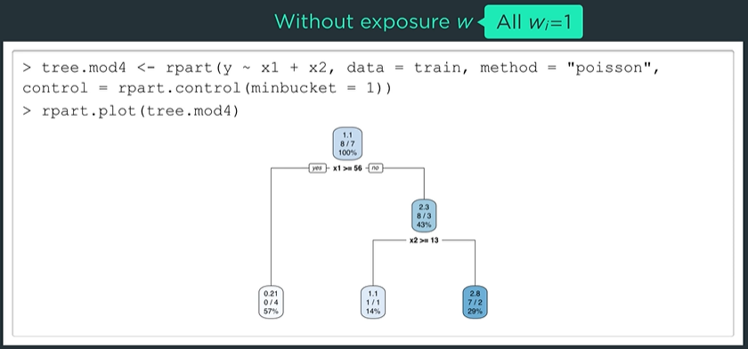

## 4.1.2 Pruning a Regression Tree

Obtain sequence of sub-trees by access the complexity parameter

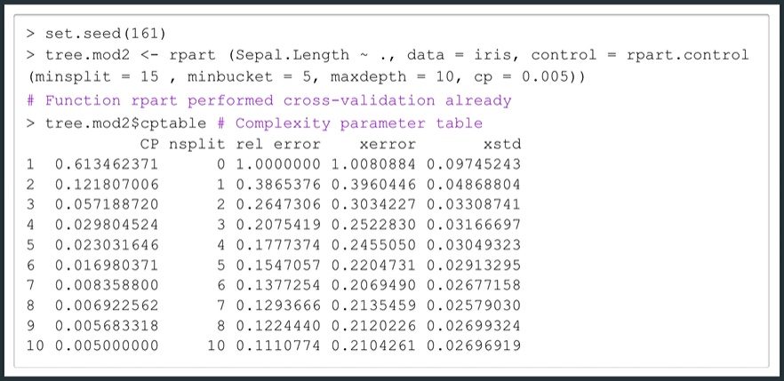

We typically prune the tree where the CV error is the lowest

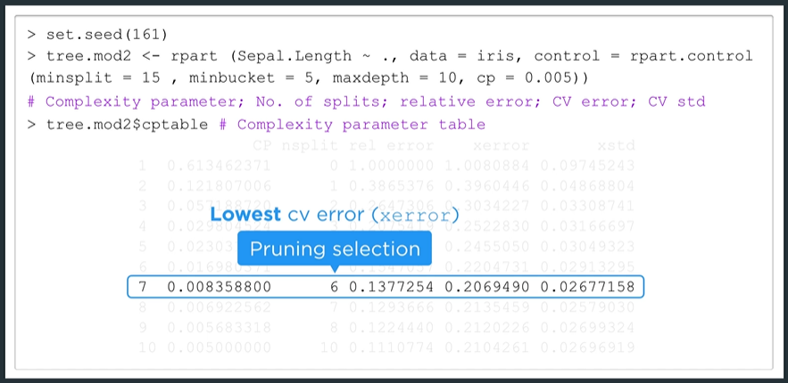

Get lowest CV error by using which.min

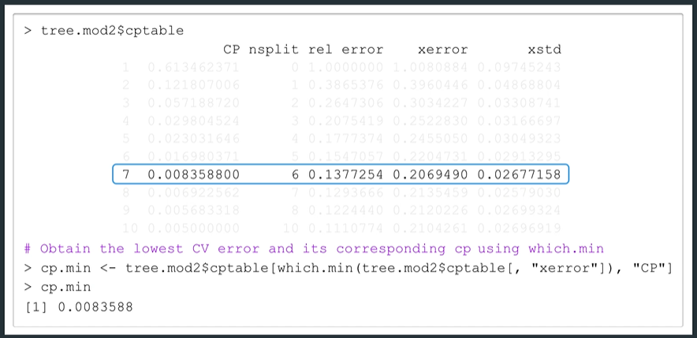

Use prune.rpart to prune the tree

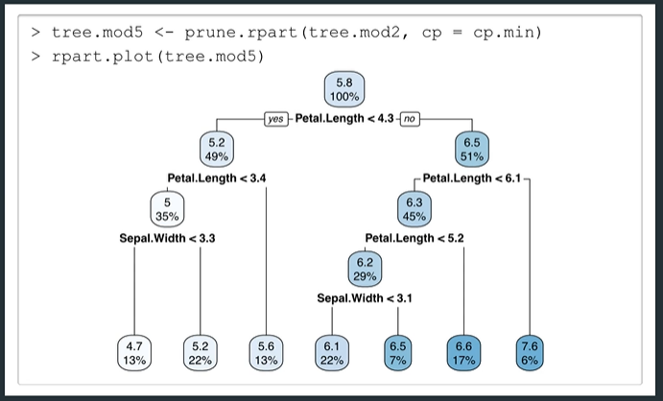

Use the one-standard error rule. The optimal model is the leftmost point that lies below the horizontal dotted line.

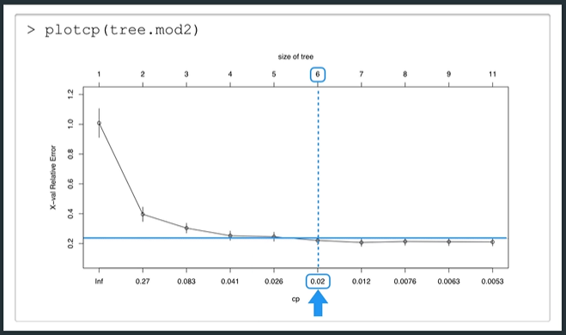

So instead of pruning at cp.min we prune at 0.02. The result looks like  
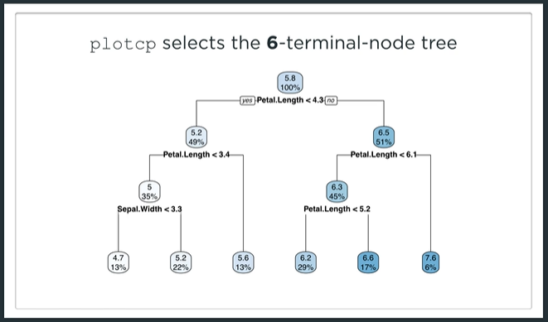

A technical note on cp values used in plotcp

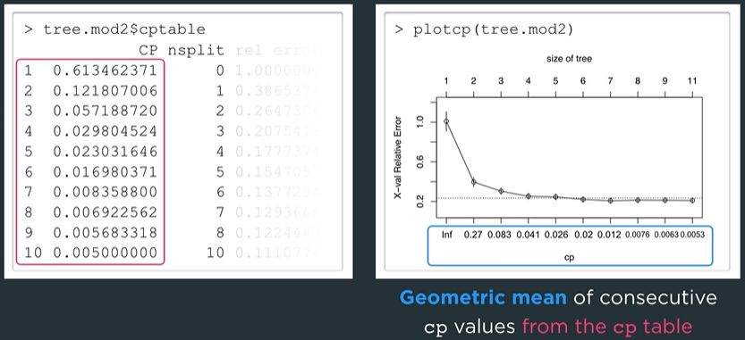

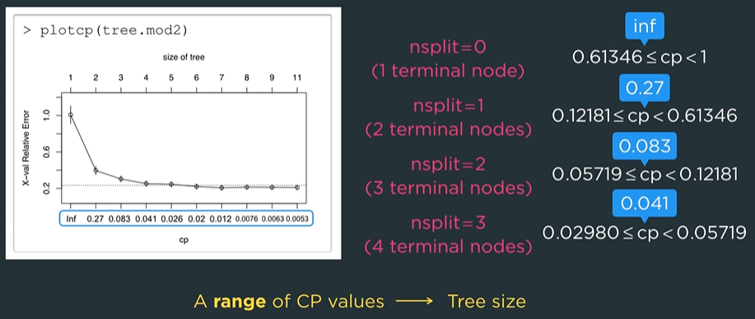

It’s risky to interpolate cp values

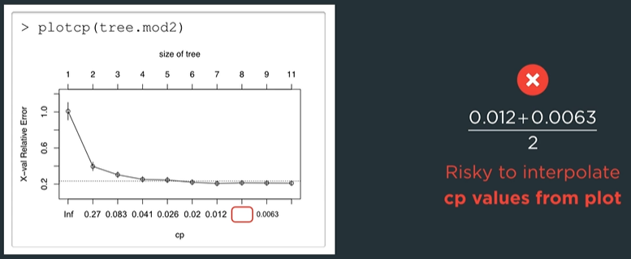

So just use cptable to get the values

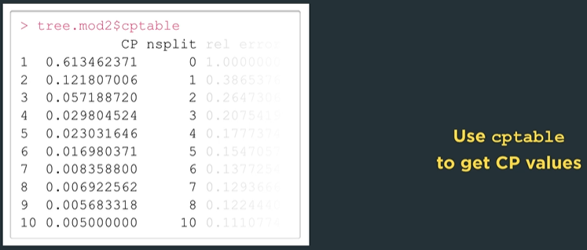

## 4.1.2 The Train Function: Part 1

The function train comes from the package caret. We can use the package rpart in conjunction with train to fit our models

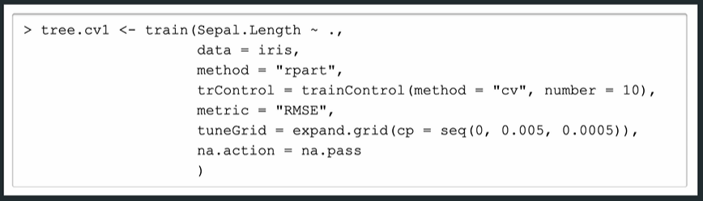

We now explain some of the arguments

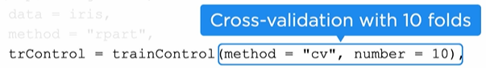



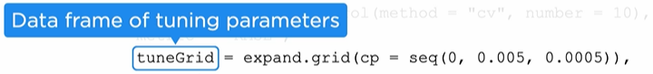

Last argument specifies what to do with missing values in the training data



We can also include the stopping criteria from rpart.control

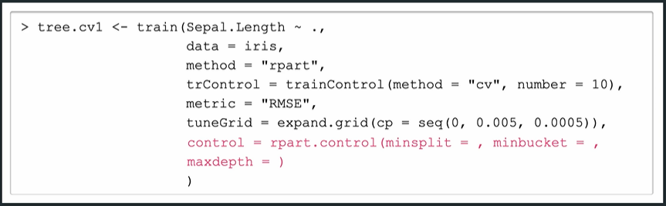

Look at RMSE vs CP

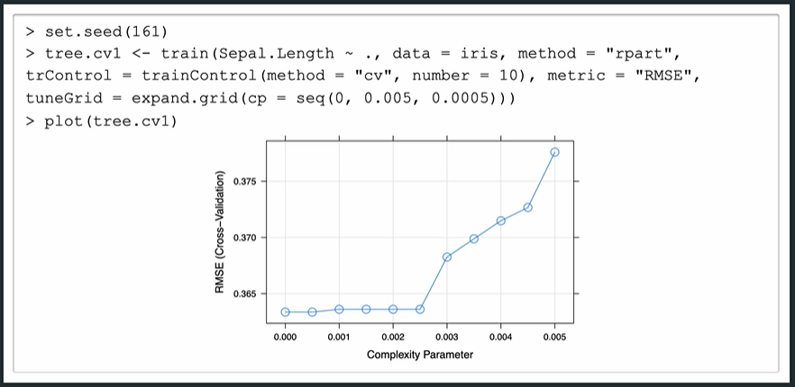

Or look at results in a tabular form

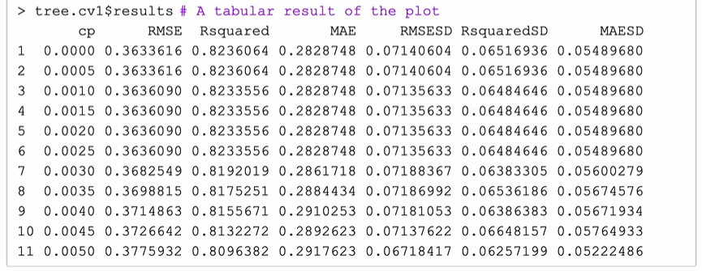

To extract the model with lowest CV RMSE

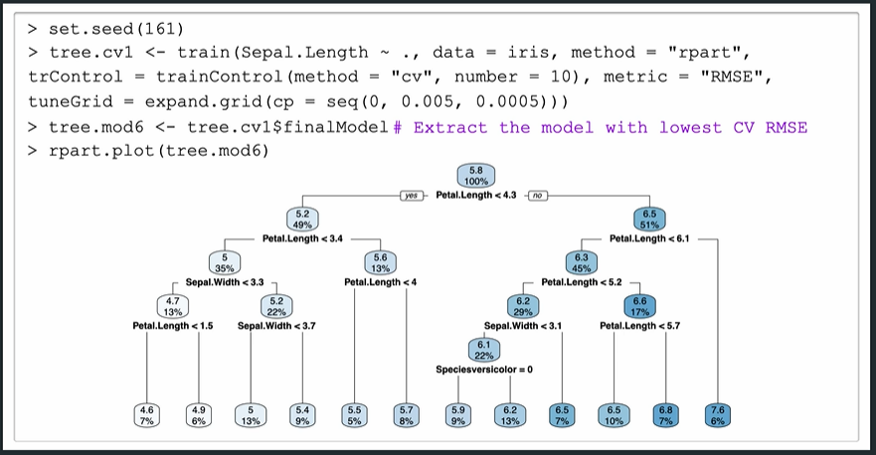

If we only want the cp with lowest CV RMSE then we can use bestTune

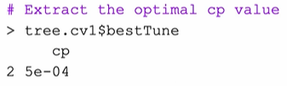

The function train creates dummy variables from the factors when a formula is used in the first argument.

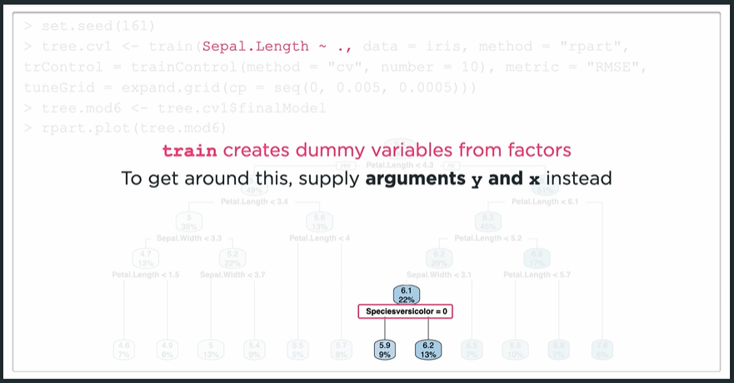

If we do things this way

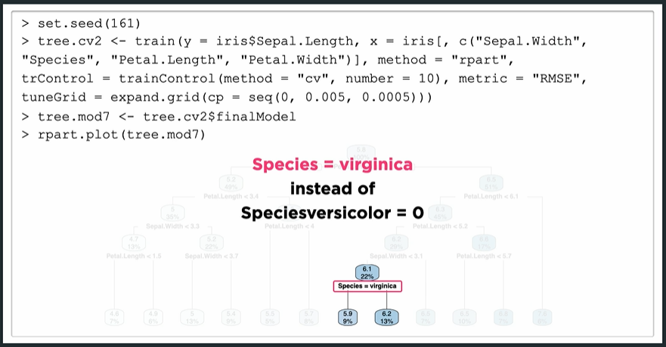

In summary we have three ways to construct a regression tree

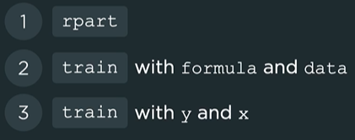

## 4.1.2 Competitor and Surrogate Splits

Some finer details about rpart. Competitor splits are the best alternatives from predictors not chosen as best split. We use surrogate splits when the training data is missing values (backup splitting rules)

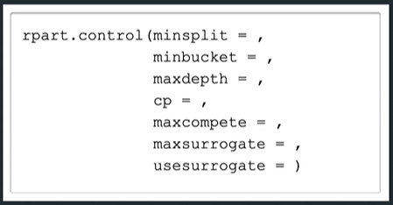

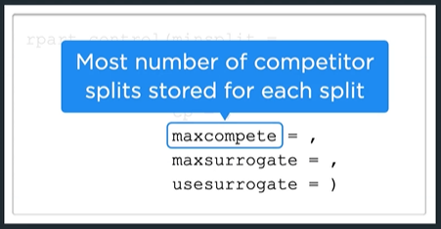

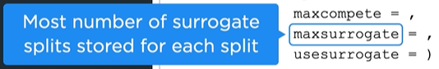

Maxsurrogate = 0 (don’t spend runtime finding surrogate splits)

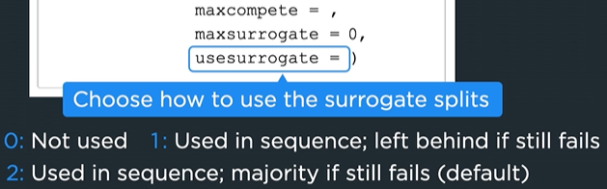

Summary gives variable importance which is how useful each variable was in constructing the tree

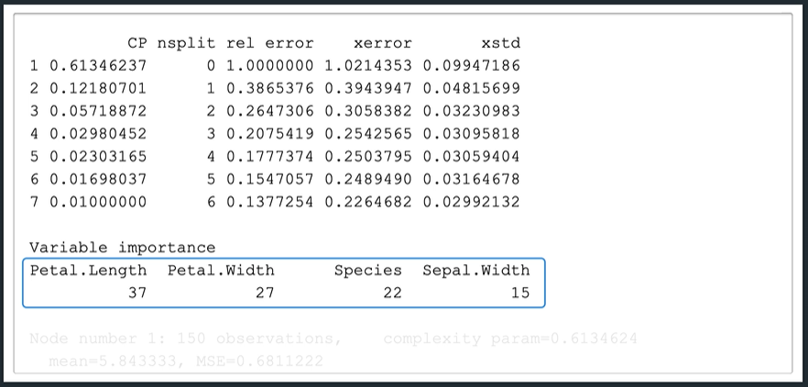

And a detailed summary of what occurs at each node. Such as competitor splits

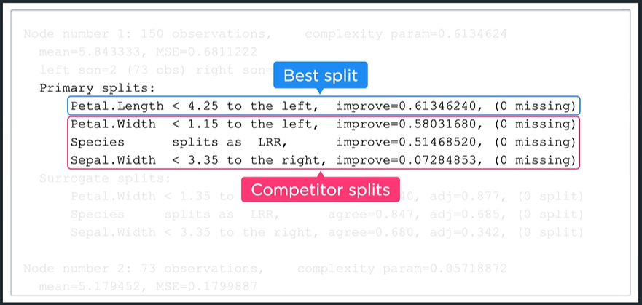

And surrogate splits

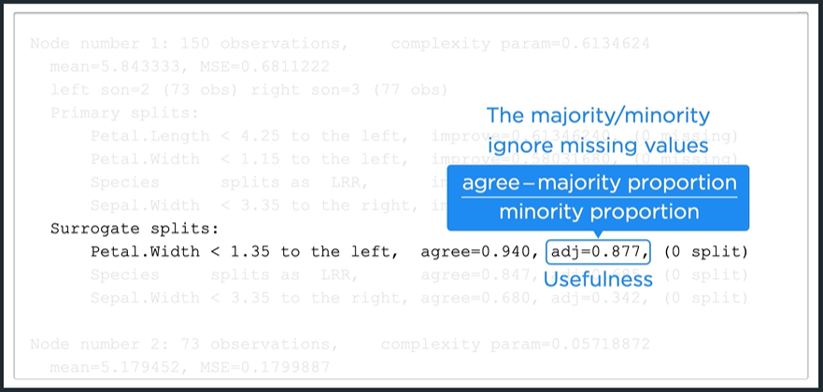

This information is available for every non-terminal node in the tree.

## 4.1.2 Constructing a Classification Tree

Classification tree uses the majority class instead of sample mean. For example, we start with the modified iris dataset.

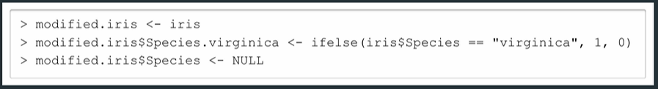

We need to use method = “class” and pass a splitting measure (Gini = gini, Entropy = information) in for the parameters.

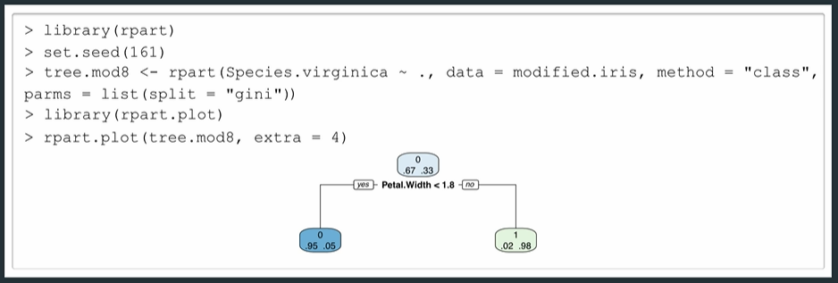

Extra = 4 displays the probabilities (proportion of obs) for each class at each node.

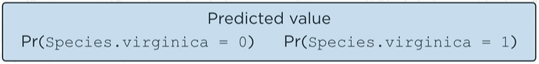

Use predict to get predicted probabilities. To get target predictions specify class for the type argument

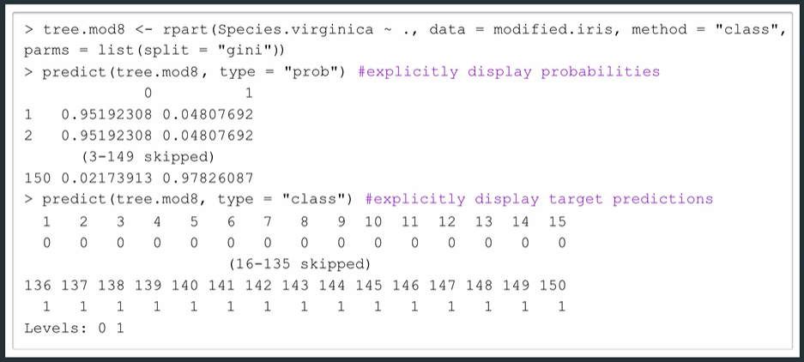

Data needed to construct the ROC curve comes from the second column of predict

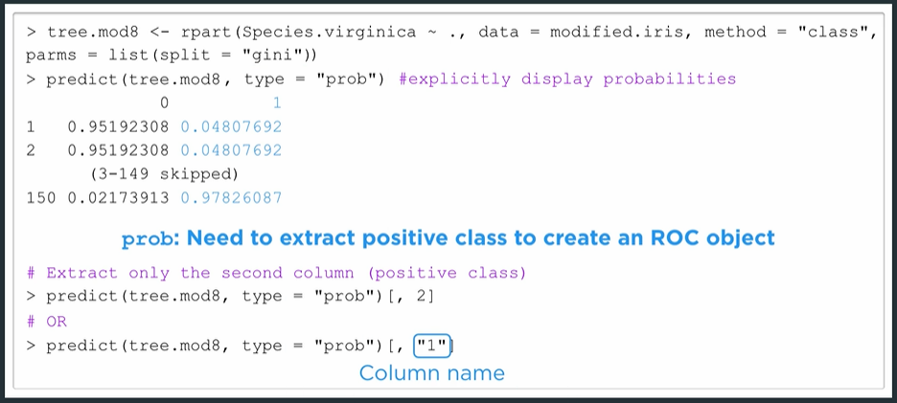

We use the target predictions to create the confusion matrix

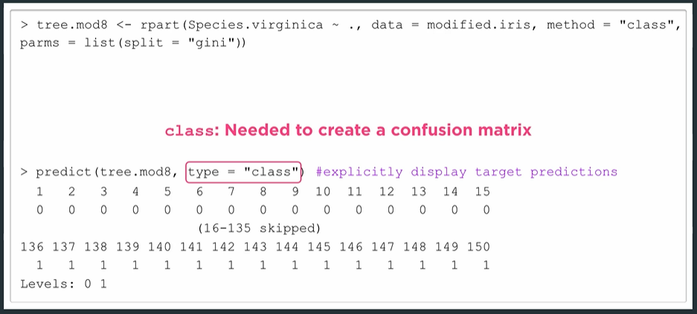

Two examples of predicting different observations.

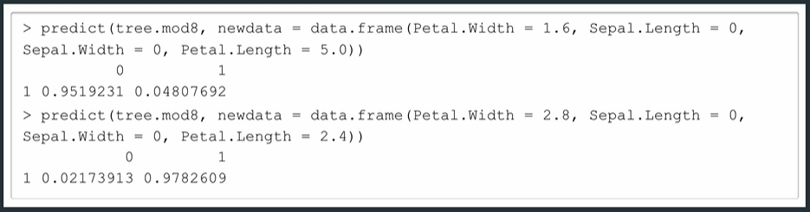

Again, we need all the predictor values even if the tree doesn’t split on them (they don’t impact the prediction).

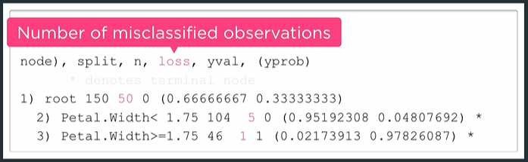

The given probabilities are simply the proportions of obs in each class

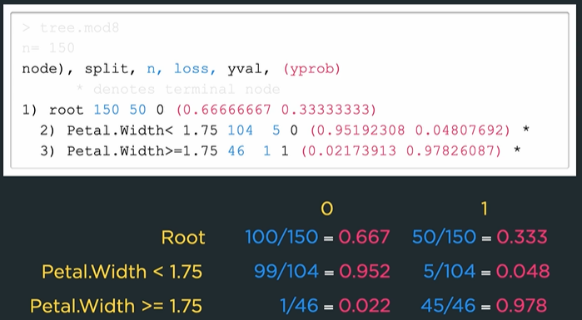

If we use entropy as the splitting rule instead, we get a different tree

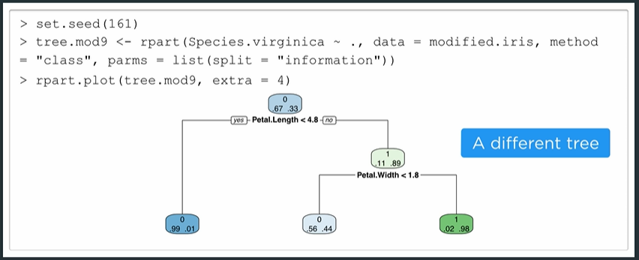

## 4.1.3 Pruning a Classification Tree

Start by extracting the complexity parameter table from the model

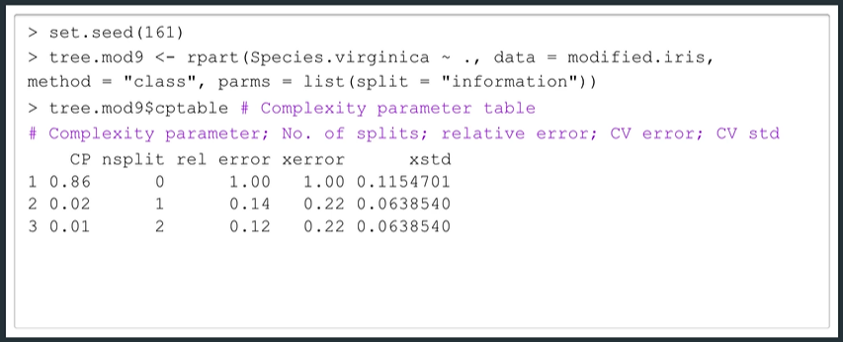

The relative error is calculated as

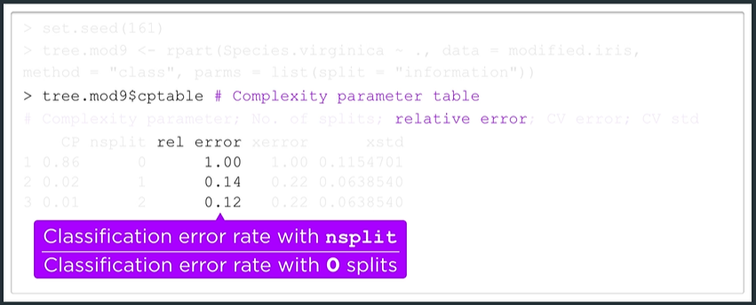

Classification error rate is the percentage of observations with wrong predictions.

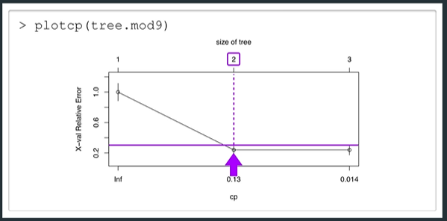

## 4.1.3 The Train Function: Part 2

Using train from package caret to fit classification tree. When fitting a classification, it’s necessary to convert the target into a factor.

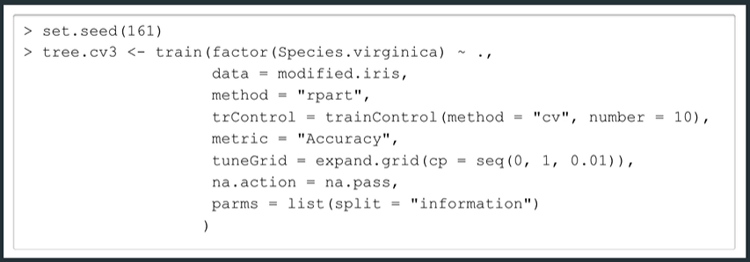

The only arguments that differ from a regression setting is metric = “accuracy” and split = “information” (entropy).

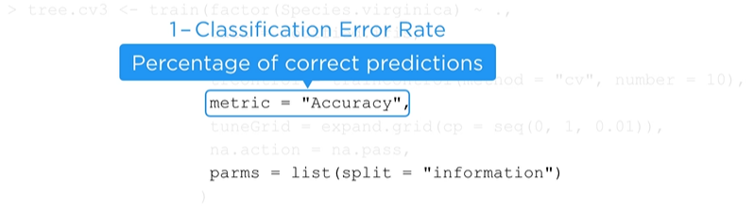

Plotting the complexity parameter table

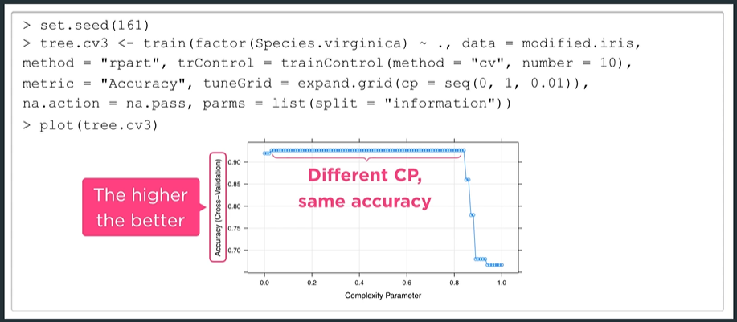

Extract highest CV and optimal cp value in the same way

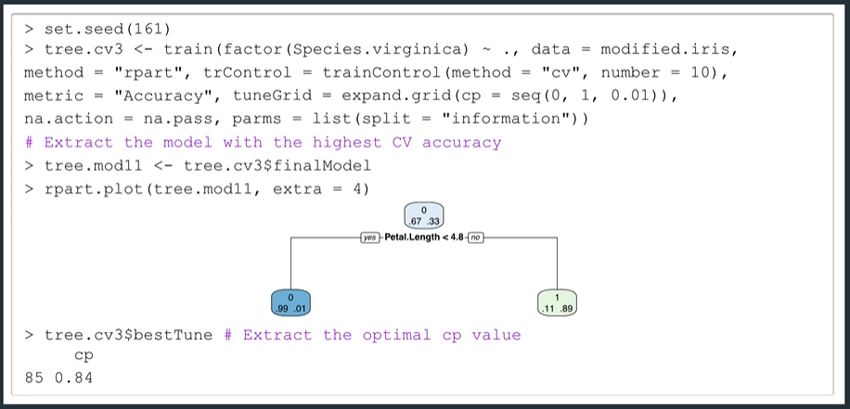

## 4.1.3 Advantages and Disadvantages

Advantages

1. Don’t require assumptions about the data
2. Easy to interpret and explain
3. Easy to present visually
4. Easy to construct
5. Insignificant predictors are removed automatically

Disadvantages

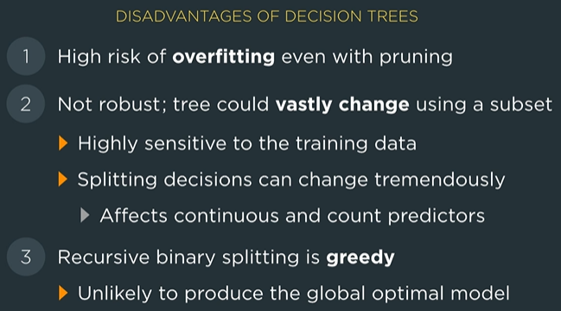

## 4.2.1 Random Forests

Ensemble methods combine multiple models to obtain one predictive model. Focus on accuracy and not easily interpretable.

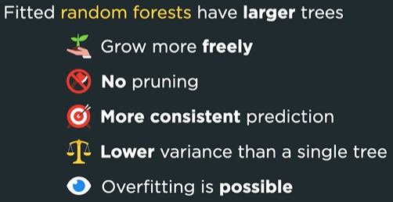

Constructing a random forest in R

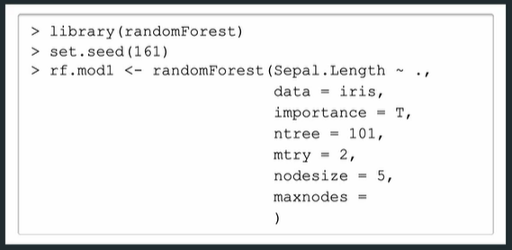

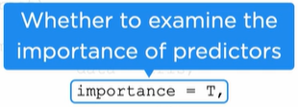

The remaining arguments control how the trees are constructed.

Ntree – number of trees to fit

Mtry – the number of features to be considered at each split

Nodesize – minimum size of the terminal nodes

Maxnodes – maximum number of terminals nodes each tree can have

Looking at the help documentation for Random Forest

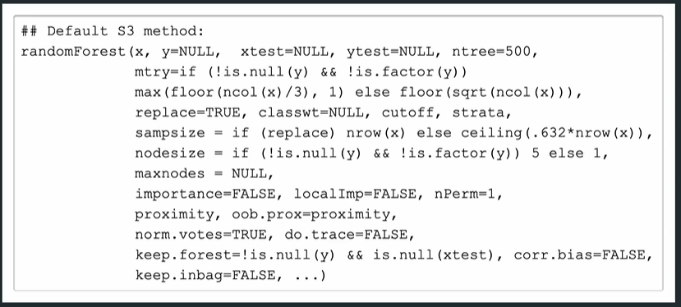

By default mtry = p/3 for regression and sqrt(p) for classification

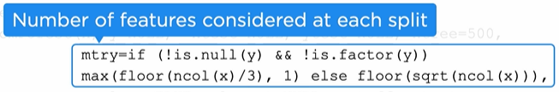

Run a random forest on the iris dataset

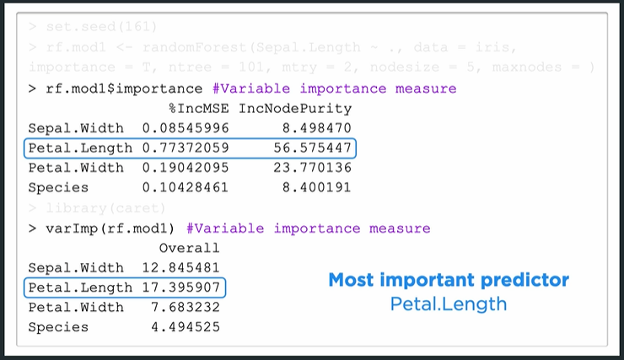

There are two ways to get the variable importance. The three measures (IncMSE, IncNodePurity, Overall) are calculated differently.

Predict does not return result in predictions on the training data but the out-of-bag observations.

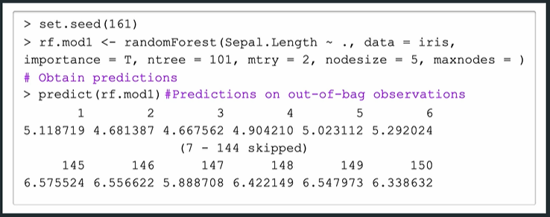

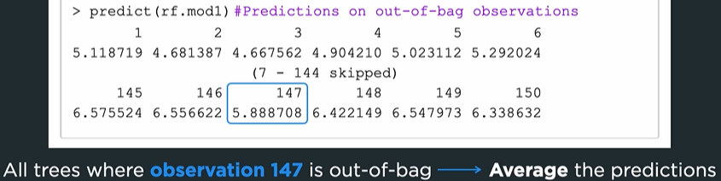

Prediction may return “NA” if it is NOT out-of-bag for all bootstrap samples.

In order to obtain predictions on the training dataset we use the newdata argument

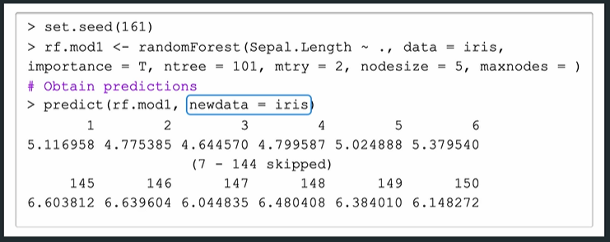

We can also obtain predictions for individual trees by setting keep.forest = True in the random forest model and then using predict.all = True in the predict function.

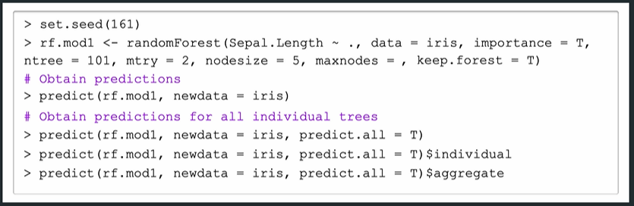

## 4.2.1 Boosting

Grow trees sequentially using information from previous trees. Reduce bias by aggregating trees.



To fit a boosted model in R we can use the gbm or xgboost package.

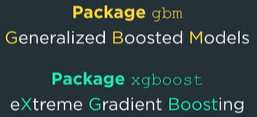

We start by using gbm

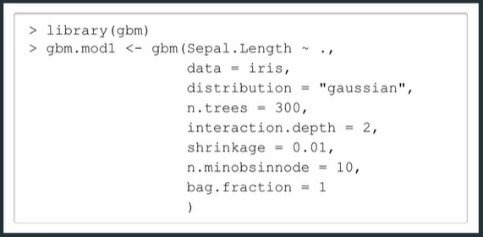

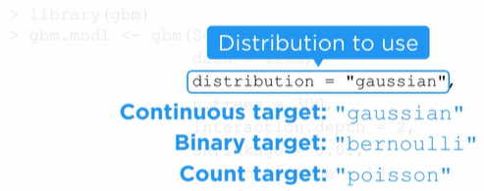

If distribution is not specified it will be inferred from the implied target variable. The remaining parameters specify boosting behavior

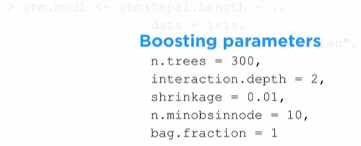

Ntrees – number of trees to fit

Interaction.depth – maximum depth

Shrinkage – shrinkage parameter

n.minobsinnode – minimum number of observations in the terminal nodes

bag.fraction – portion of the training observations used for each tree (this is done randomly when fraction < 1, so set the seed to create reproducible results)



Use summary function to access variable importance measure

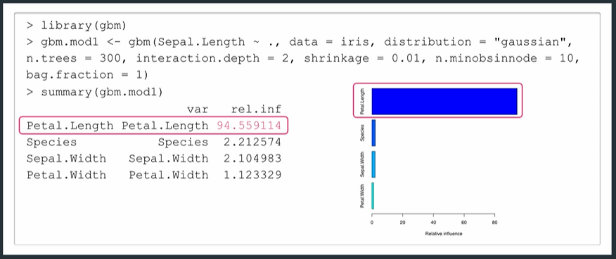

Predict values with the predict function

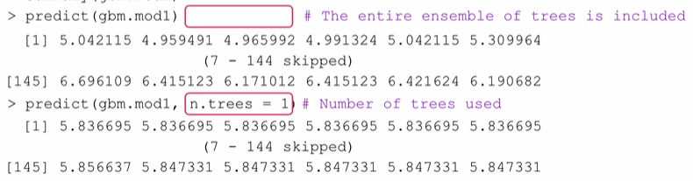

Using xgboost requires a special data type for the dataset. The following reconfigures the dataframe for the training data.

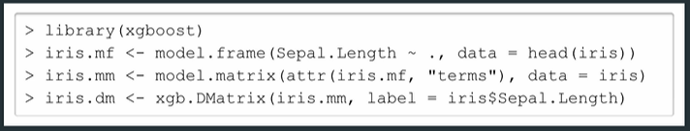

We must do the same with the test dataset if needed.

Use xgb.train to perform boosting. Requires dataset, nrounds and params. No formula is included because the target and predictors were all specified when the dataset was previously reconfigured.

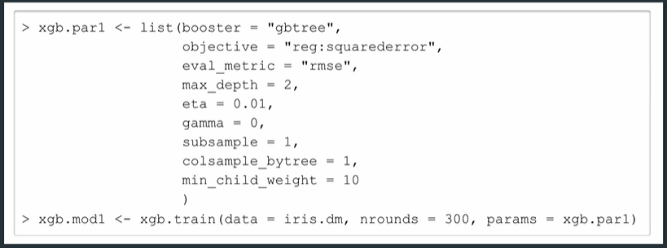

Model parameters

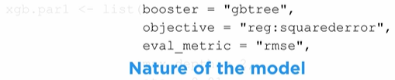





Boosting parameters

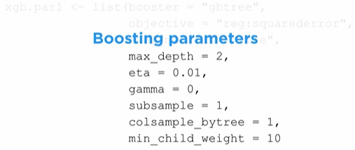

Max_depth – maximum depth of each tree

Eta – shrinkage parameter

Gamma – minimum reduction of splitting measure

Subsample – proportion of data used for training each tree

Colsample_bytree - proportion of predictors used in training each tree

Min_child_weight – dictates when splitting stops.

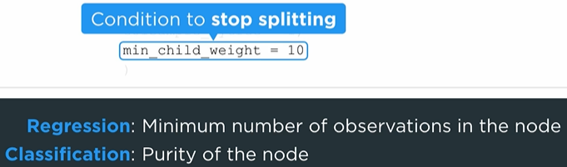

Look at model results with xgb.importance

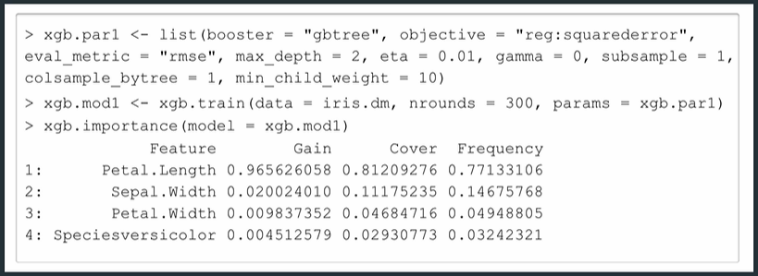

Focus on Gain column

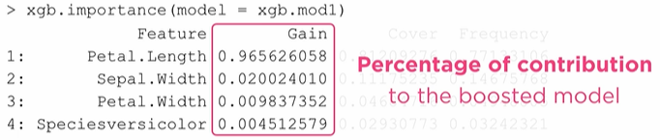

Use function predict to obtain the predictions. There isn’t a default for the dataset here. We use the newdata argument to get the training predictions

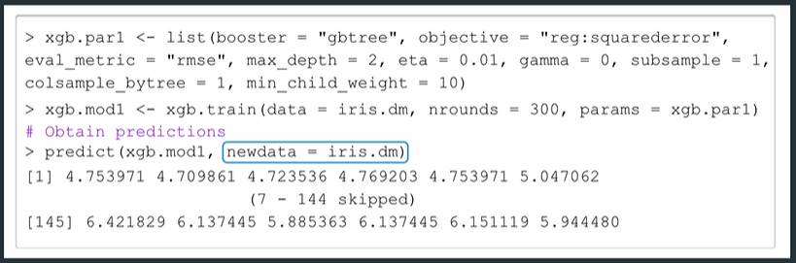

We find the optimal number of trees using cross-validation

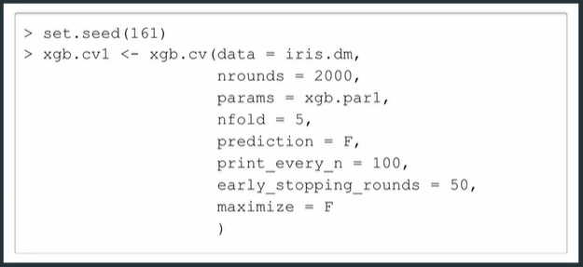

Arguments relate to how the model is trained

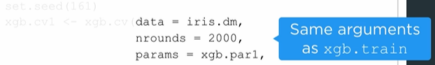

And to how the cross-validation is performed/shown

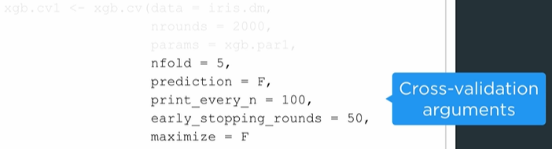

Output like the following will appear line-by-line as the code runs

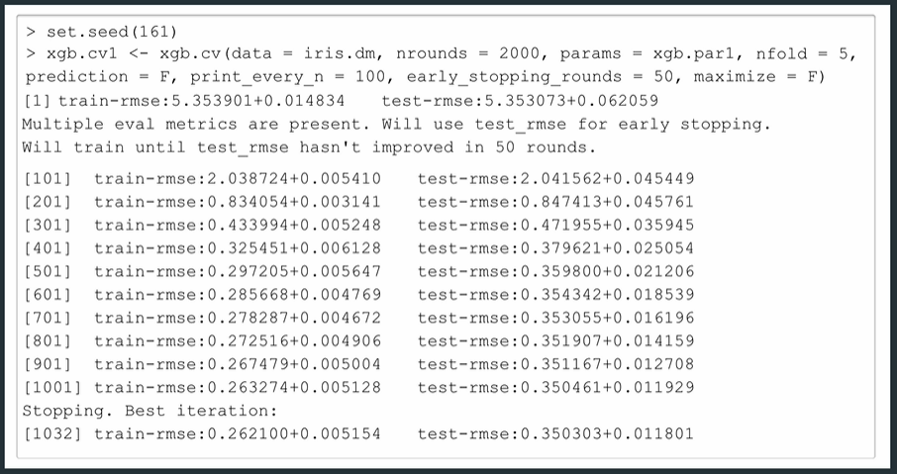

The last line indicates the optimal value for nrounds

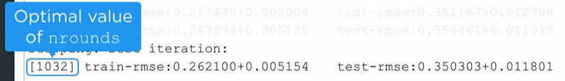

We can extract this number and use it as an argument for training

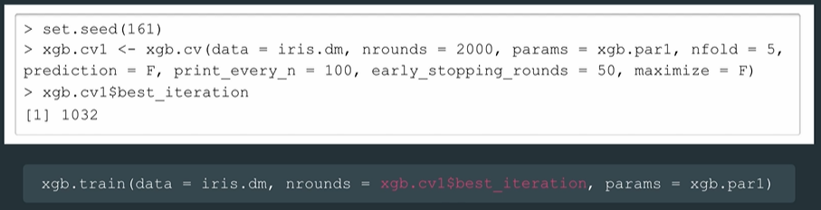

## 4.2.2 Oversampling and Undersampling

Oversampling – duplicate observations in the minority class

Undersampling – remove observations from the majority class

These techniques are performed on the training set only, not the entire dataset. Otherwise, a duplicated observation may end up in the test set.

Oversampling

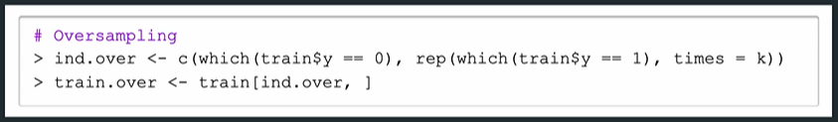

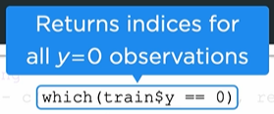

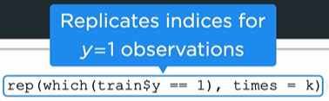  


Undersampling

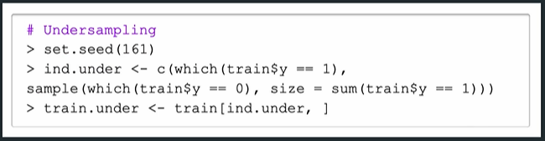

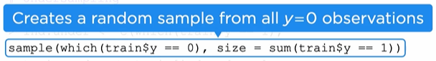

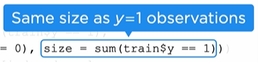

Alternatively, we can undersample by using this code

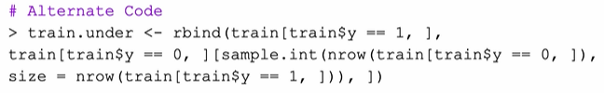



## 4.2.2 The Train Function: Part 3

We start with a modified iris dataset

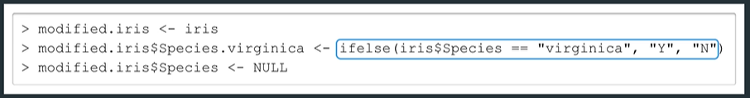

Sample code to fit a random forest model. Use method = “rf” for random forest.

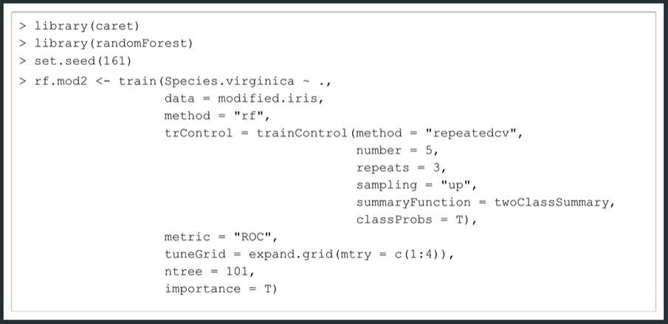

For trControl we perform repeated cross-validation with 5-folds and 3-repititions

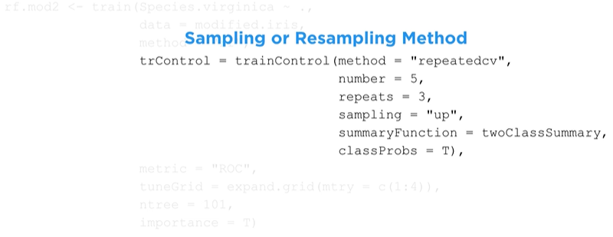

Repeated cross-validation tends to be more accurate since we get different fold assignments to result in different estimates. We also perform oversampling with sampling = “up”.

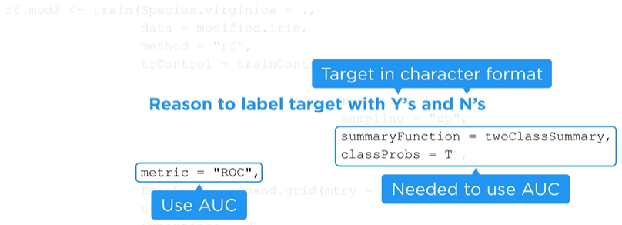



Tuning parameters



Plotting the model we have

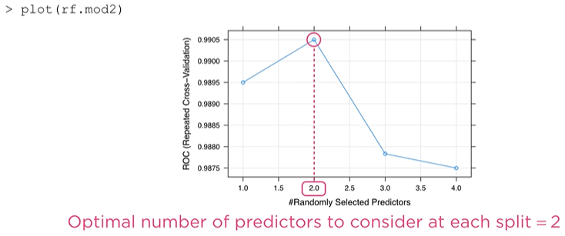

How can we use the function train to fist a boosted model. Start by loading the package gbm and train

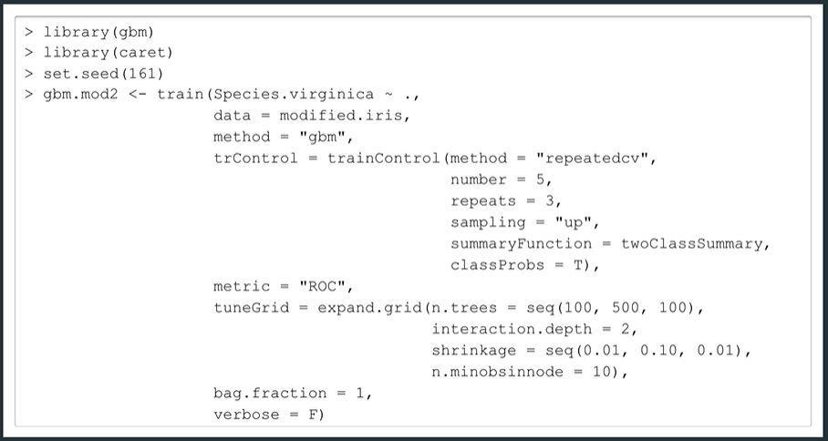\

The boosting parameters go into tuneGrid

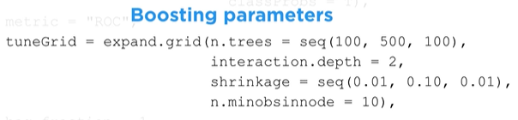

Our grid contains 5x1x10x1 = 50 combinations

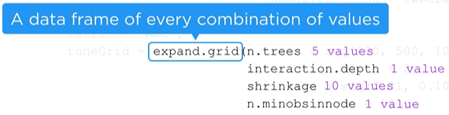

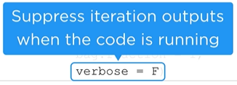

Plotting gives the cross-validation AUC for all 50 combinations from expand.grid

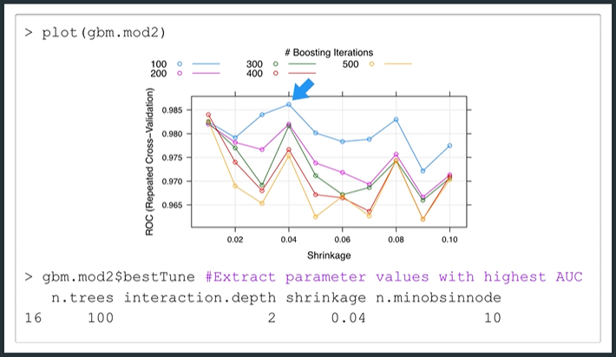

We repeat the training with xgboost package. This time we use method = “xgbTree”. Unlike xgb.train we do not need to reconfigure the dataset.

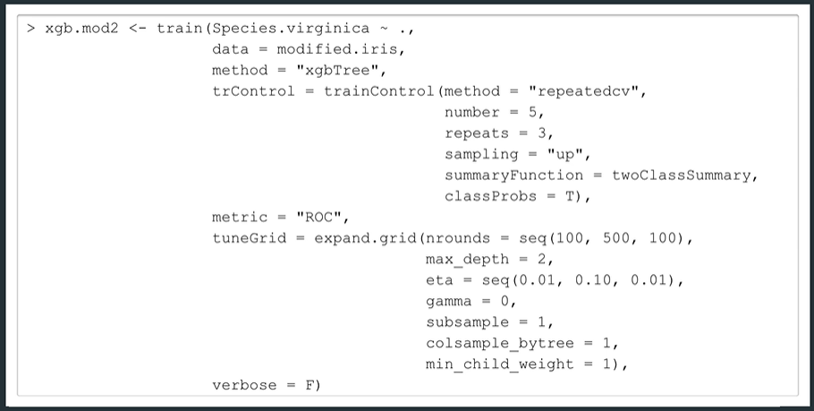

Plotting

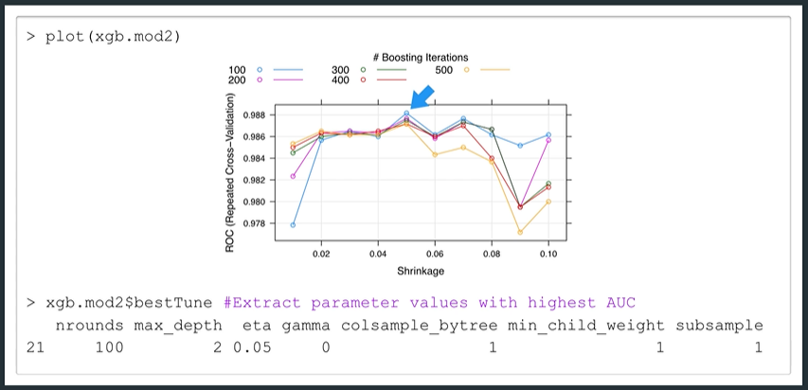

A summary of what the train function can work with

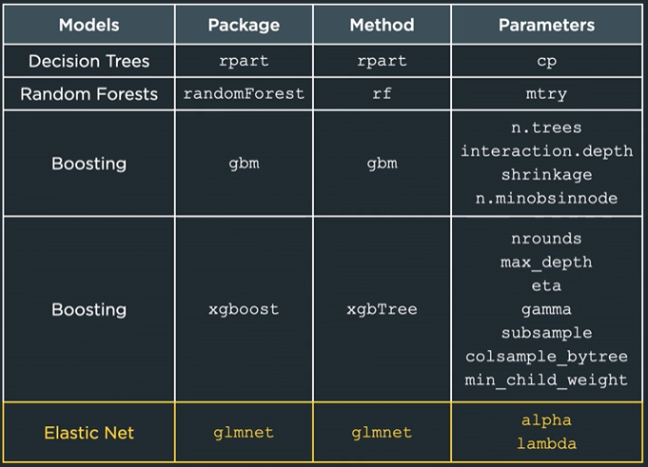

For Elastic Net we don’t need tuneGrid to specify what values of alpha and lambda to consider

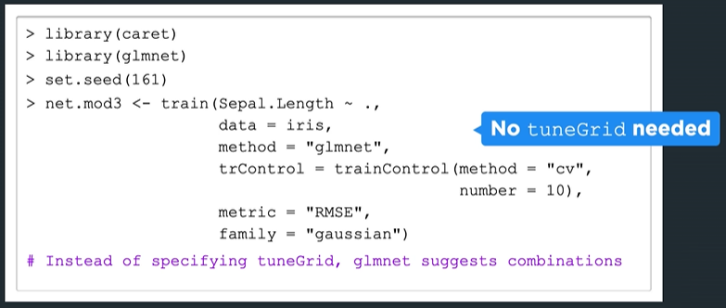

From the output there are 9 combinations

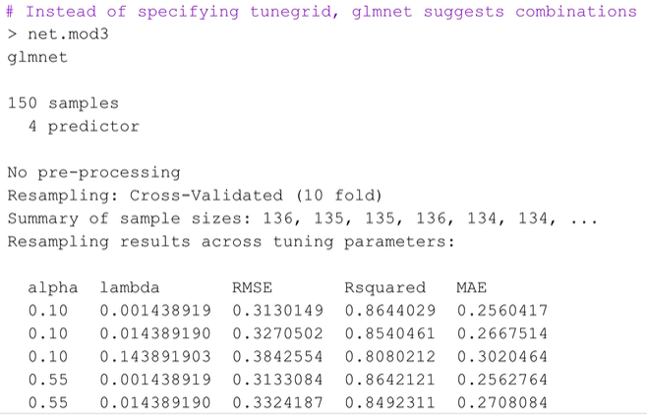

With the best one listed at the end

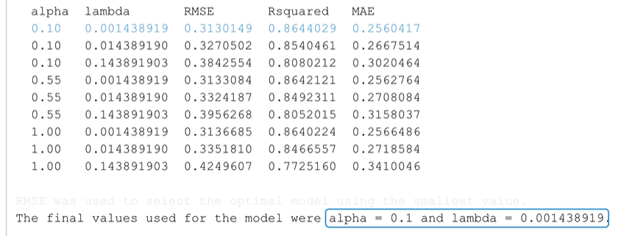

This allows us to tune alpha and lambda together with cross-validation

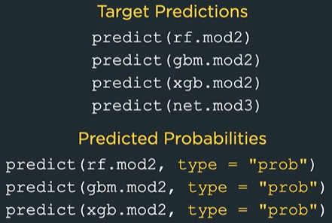

But we don’t use predictions on the extracted final model

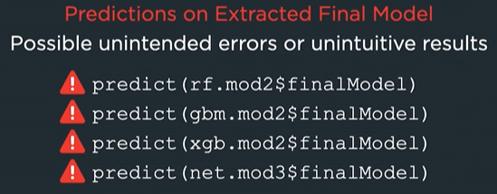

<https://stackoverflow.com/questions/54075778/r-caret-values-of-finalmodelpredicted-and-values-obtained-by-predict>

<https://stats.stackexchange.com/questions/81609/is-preprocessing-needed-before-prediction-using-finalmodel-of-randomforest-with>

## 5.1.1 Principal Components Analysis

Perform PCA by using the function prcomp from the base package

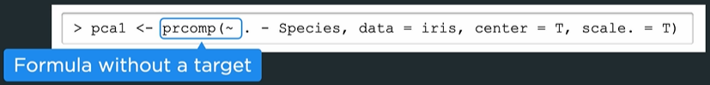

We exclude species because prcomp does not work with factors. Also notice there is not target variable in the formula because PCA is an unsupervised method.

Alternatively, we can provide prcomp with the data component like this



We standardize (center and scale) before performing PCA. By default, center = True as the function prcomp requires centering.

We can access the loadings with rotation attribute

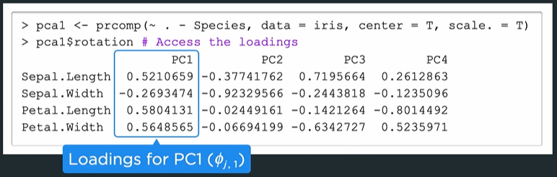

The PCs give us an indication of the amount of correlation present between variables

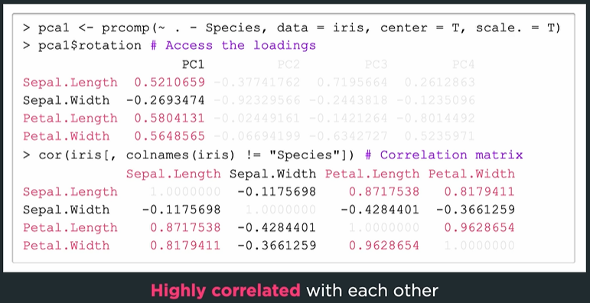

To get the Principal Component scores

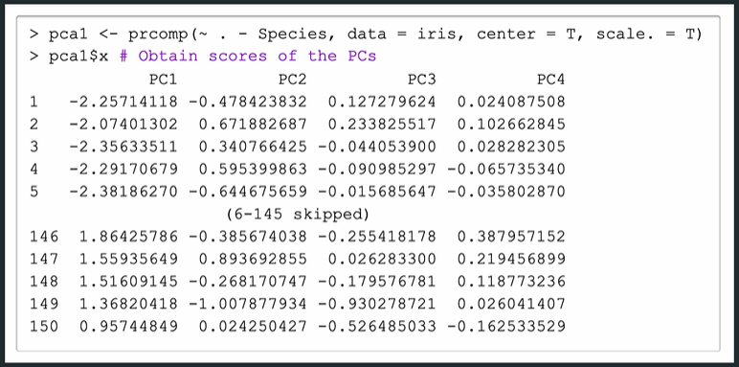

We can also compute these manually

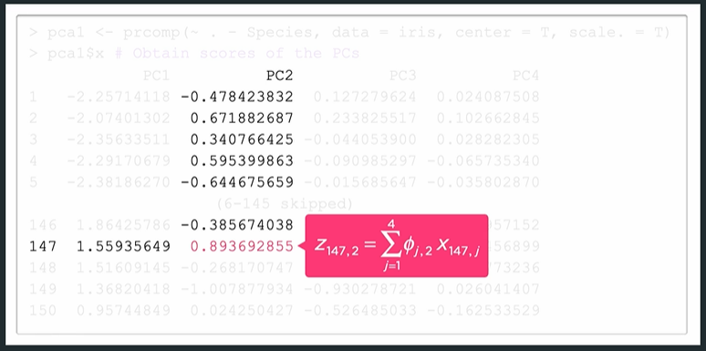

Look at the loadings and the variable values. Note that loadings and scores are unique up to a sign flip.

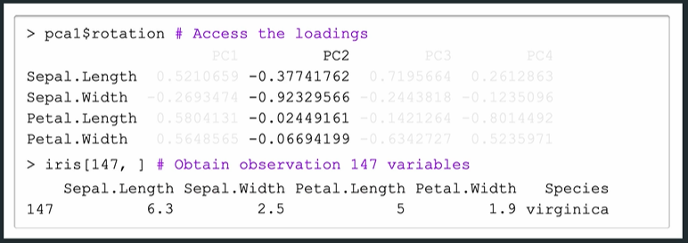

But remember we must standardize the variables first

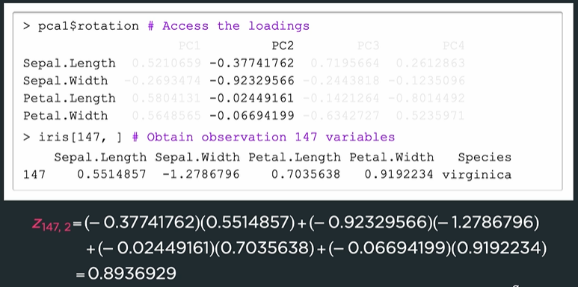

We can visualize loadings and scores with biplot

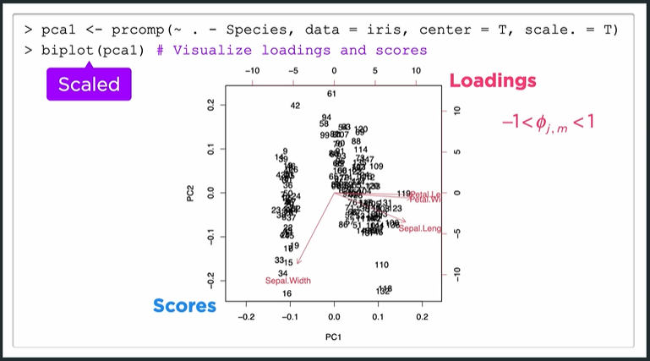

The biplot is scaled to improve how the plot looks (loadings should be [-1,1] but are displayed as [-10,10]). If we set the scale = 0 we can create the unscaled biplot.

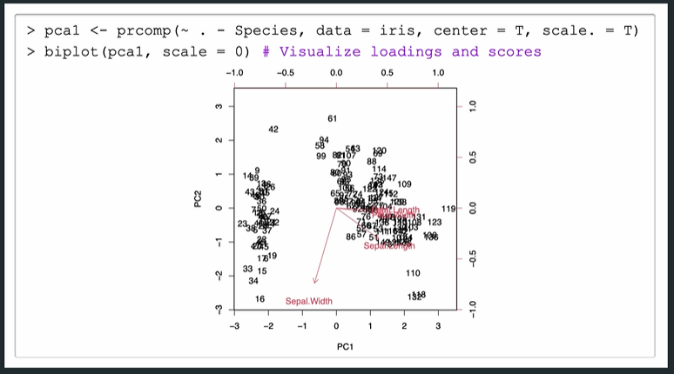

The general shape is still the same as can be seen with this side-by-side comparison

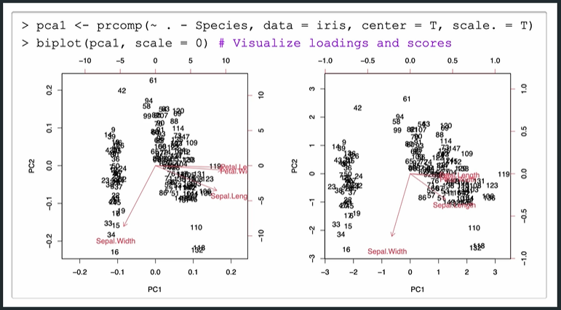

We can interpret individual points on the biplot. For example, point 119

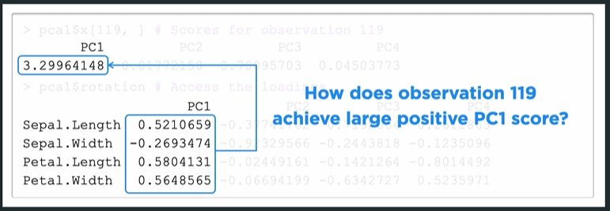

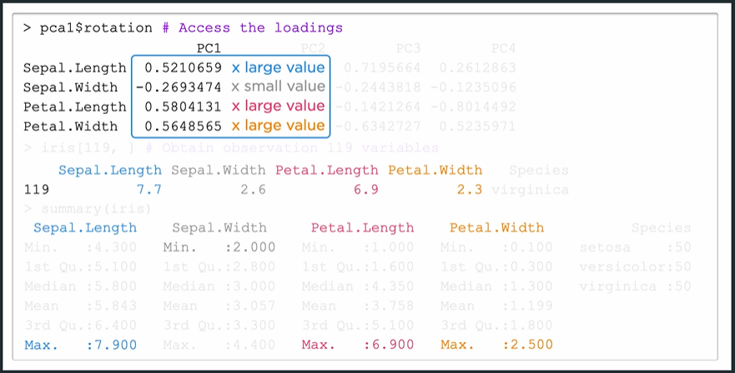

The principal component explain variance in the data

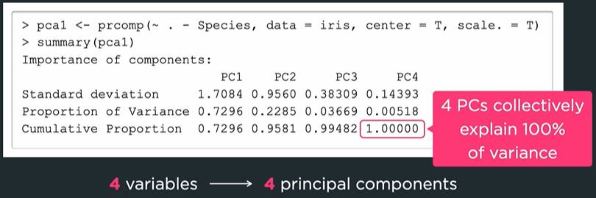

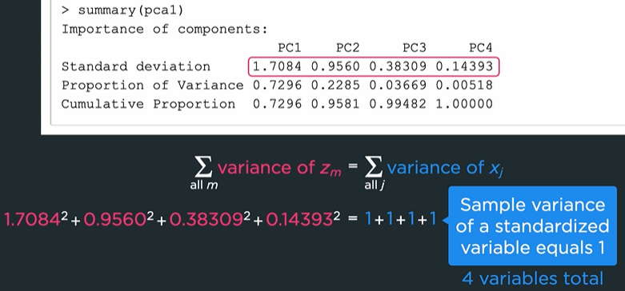

Use Scree plot to visualize variance explained

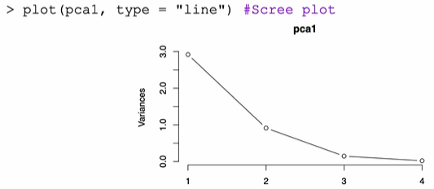

Or use the screeplot function

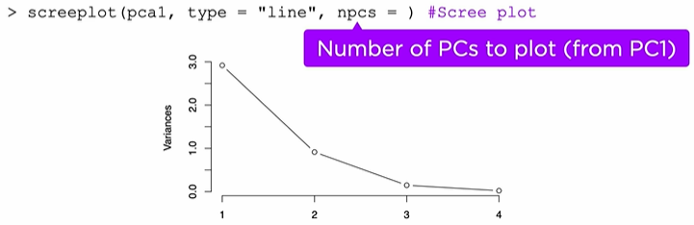

Use the first principal component in place of all the features

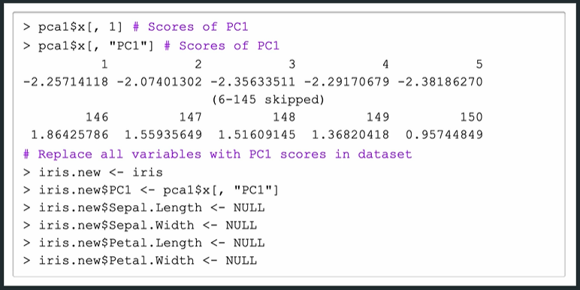

## 5.1.1 Technical Details

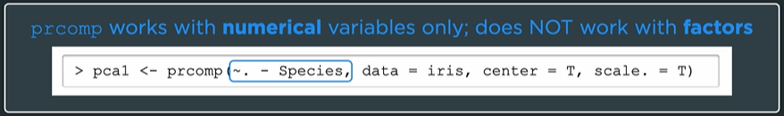

If we want to include factors, we need to binarize them and include dummy variables in the analysis. We need to make sure every level has its own variable, so we specify fullRank = False

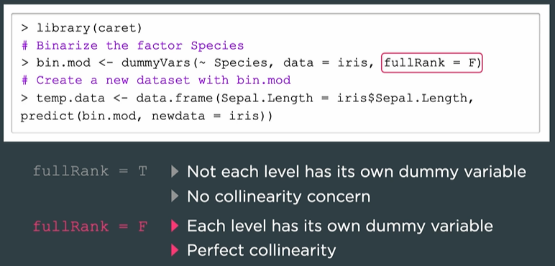

However, performing PCA on factors is a bit controversial in literature.

To use PCs as new features we use the following code (easy and direct).

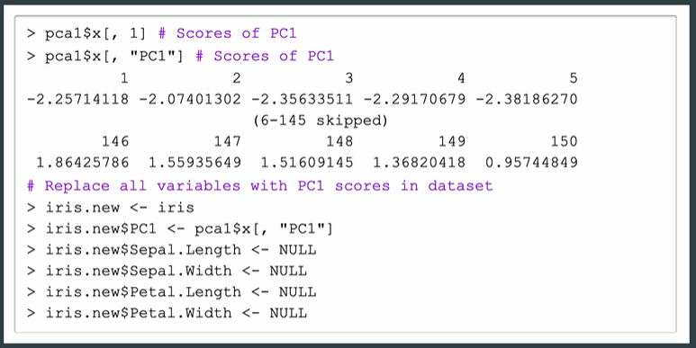

But this can be done in other ways as well.

## 5.2.1 k-Means Clustering

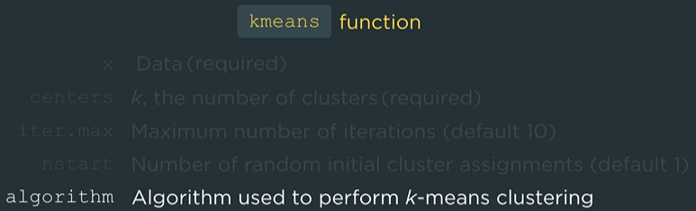

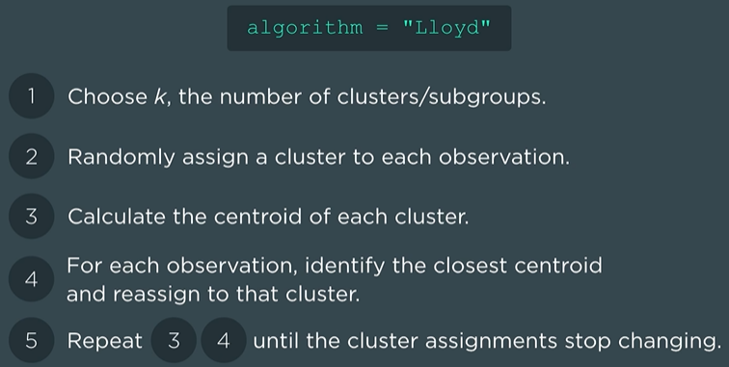

We perform k-Means clustering with k = 5 on the iris dataset. We first scale the dataset and the cluster on the sepal width and length.

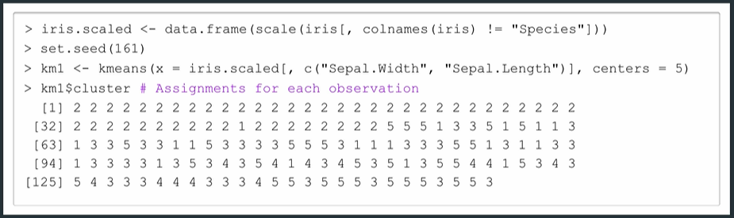

We visualize the cluster assignments by assign cluster assignments to color argument

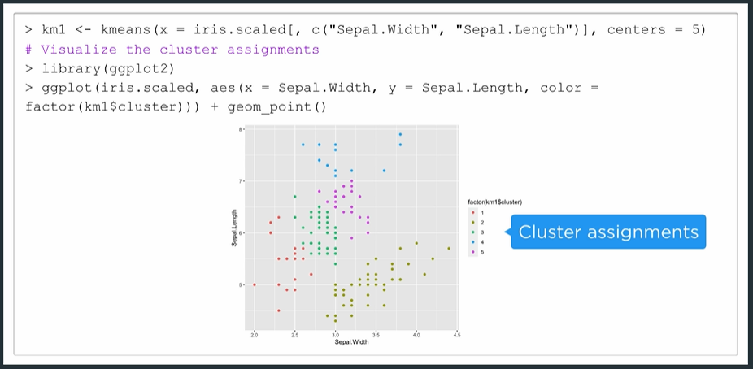

If we re-run the same code without resetting the seed, we will get different cluster assignments because the initial assignment is random. This algorithm finds the local minimum of within cluster variation.

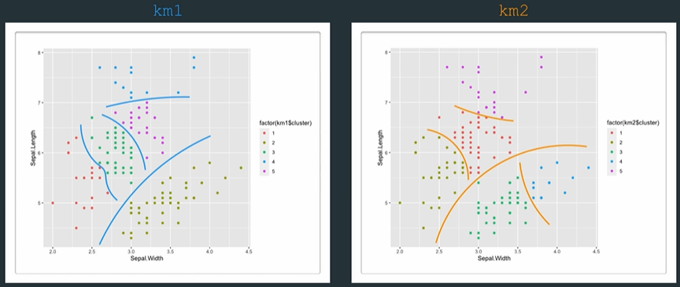

We increase nstart = 30 and extract the total within-cluster variation

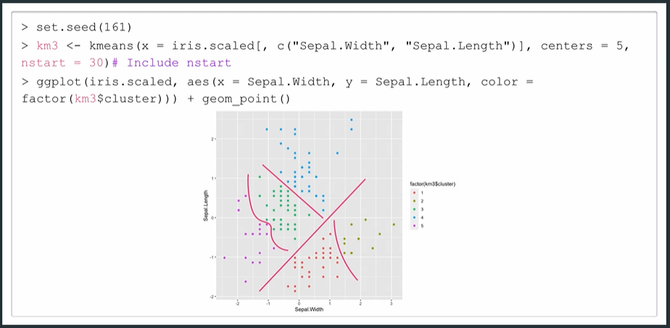

A greater nstart is more likely to get us closer to the global minimum

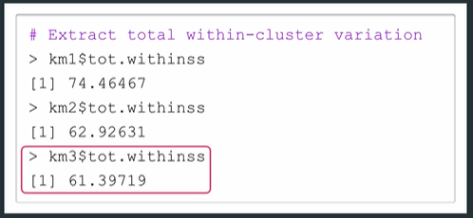

We use the elbow method (subjective) to find the optimal value for k

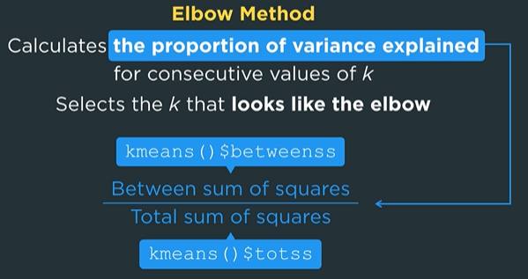

Code for the elbow method could look like

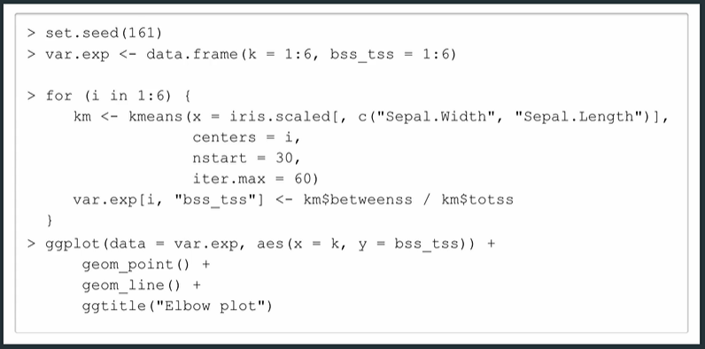

The elbow is not always obvious

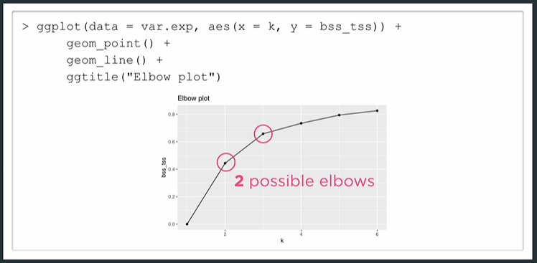

## 5.2.2 Hierarchical Clustering

Agglomerative (bottom-up) hierarchical clustering.

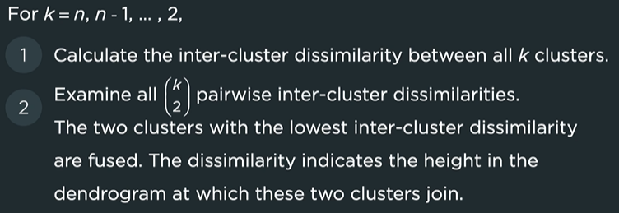

With 4 common linkages

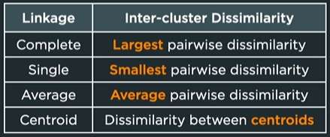

To perform hierarchical clustering in R we use the hclust function

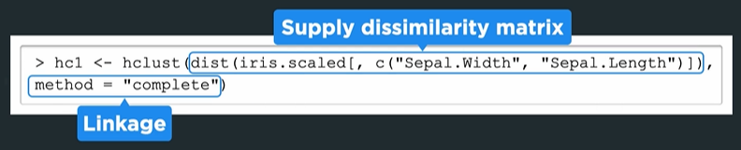

The function dist returns the Euclidean distance (by default) when supplied with a dataset. Next we plot the dendrogram.

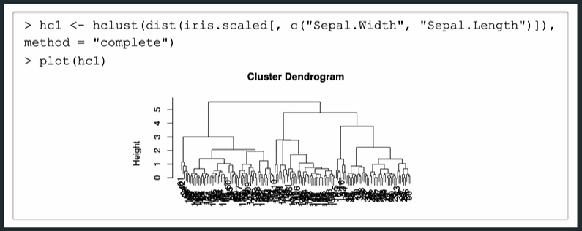

We obtain cluster assignments by using the function cutree. We can specify the height or number of clusters

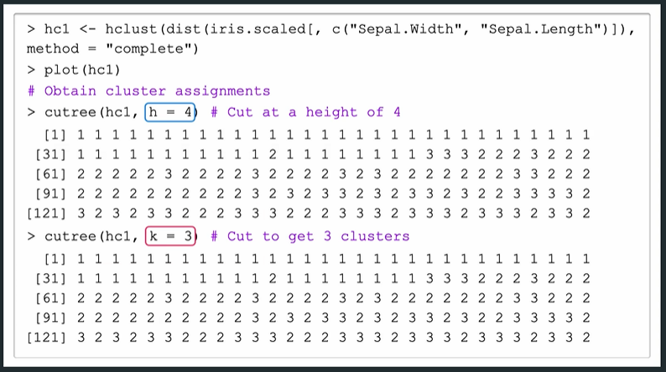

Use ggplot as before to plot hclust

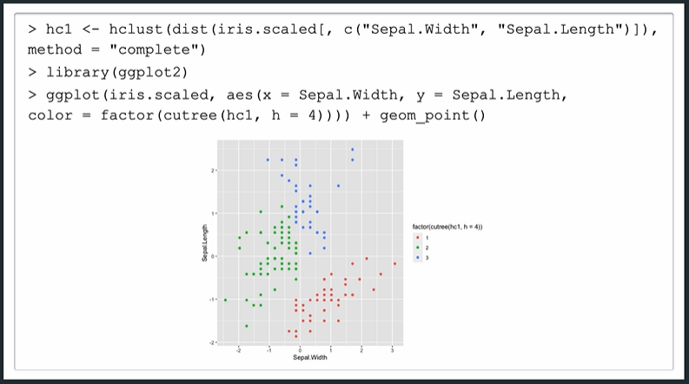

One peculiarity is we need to supply the squared Euclidean distances when using the centroid linkage

